Materials Management (MM)
This case study explains an integrated materials management process in detail. This promotes a thorough understanding of each process step and the underlying SAP functions.

Product  S/4HANA 2020  Global Bike  Fiori 3.0  Level  Bachelor's degree  Masters  Beginner  Focus  Materials Management  Authors  Bret Wagner  Stefan Weidner  Version  4.1  Last Change  June 2022 | MOTIVATION  In the exercises for Materials Management, a procurement process was tracked with master and transaction data that had already been created.  This case study explains and executes a complete material procurement process from the creation of master data, through purchasing to payment for the delivered goods. |  | PREREQUISITES  Before you process the case study, you should familiarize yourself with the navigation in the SAP system.  To successfully perform this MM case study, it is not necessary to have completed all MM exercises. However, it is recommended.  NOTES  This case study uses the model company Global Bike, which was developed exclusively for SAP UA Curricula.  



 | Process Overview
Learning objective Understand and execute an integrated procurement process.  Scenario To process a complete procurement process, you will assume various roles within Global Bike, for example: Purchaser, Warehouse Worker, Accounting Clerk. In general, you will work in the Materials Management (MM) and Financial Accounting (FI) departments.  Employees involved Joyce Hausman (Contract Manager)  Sandeep Das (Warehouse Supervisor)  Sergey Petrov (Warehouse Employee)  Wilton Saban (Inventory Supervisor)  Alberto Conti (Inventory Assistant)  Aura Maxwell (Purchasing Agent)  Tatiana Karsova (Goods Receipt Clerk)  Silvia Cassano (AP Accountant)  Shuyuan Chen (Head of Accounting) |  | Time 170 min
Before you start the procurement process, you must create a new supplier (Mid-West Supply from Lincoln). You then create the new master record for a trading good (chain lock) in the system. After the stock is checked (empty), you initiate the procurement by creating a purchase requisition. You then generate a request for quotation and maintain the quotations for three different vendors (including your new vendor). After evaluating and accepting the bid from Mid-West Supply, you create a purchase order with reference to the original purchase quotation. You will then post the goods receipt document and confirm the physical receipt into warehouse stock. After creating two partial invoices, you will post the payment to the supplier and finally check all involved G/L accounts in financial accounting. The following graphic shows the entire process.
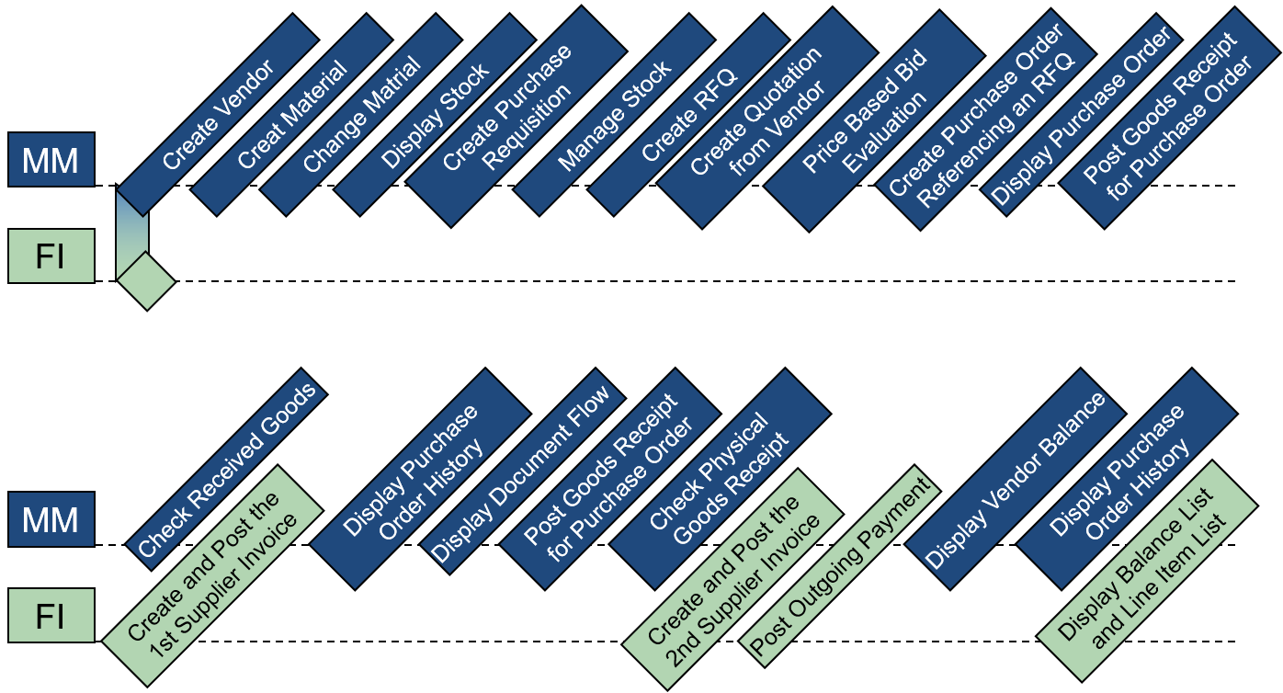
Table of Contents
Process Overview 2
Step 1: Create Vendor 4
Step 2: Create Material 8
Step 3: Change Material 13
Step 4: Display Stock 15
Step 5: Create Purchase Requisition 17
Step 6: Manage Stock 20
Step 7: Create RFQ 22
Step 8: Create Quotation from Vendor 25
Step 9: Price Based Bid Evaluation 28
Step 10: Create Purchase Order Referencing an RFQ 30
Step 11: Display Purchase Order 34
Step 12: Post Goods Receipt for Purchase Order 36
Step 13: Check Received Goods 40
Step 14: Check Physical Goods Receipt 43
Step 15: Create and Post the First Supplier Invoice 46
Step 16: Display Purchase Order History 49
Step 17: Display Document Flow 52
Step 18: Post Goods Receipt for Purchase Order 55
Step 19: Check Physical Goods Receipt 57
Step 20: Create and Post the Second Supplier Invoice 59
Step 21: Post Outgoing Payment 62
Step 22: Display Vendor Balance 64
Step 23: Display Purchase Order History 66
Step 24: Display Balance List and Line Item List 69
MM Challenge 71

 | Step 1: Create Vendor
Task Create a new supplier.  Description Use the SAP Fiori launchpad to create a new supplier (Mid-West Supply).  Name (position) Joyce Hausman (Contract Manager) |  | Time 20 min
Suppliers are used in both financials and procurement. The master record of a vendor includes 3 categories – General Data, Finance, and Procurement. Vendors can be created centrally or with shared responsibilities. During central creation, all views are generated in one step and by one person. In the case of shared responsibility, finance and procurement create the views that are relevant for them. In this case study, the vendor is created centrally. As a result, the vendor master record contains all the information required to perform business transactions. |  | Vendor Master
To create a new supplier, go to the Materials Management space. In the Contract Manager section, you can use the Manage Business Partner Master Data app. |  | Start
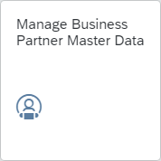
The following screen appears:
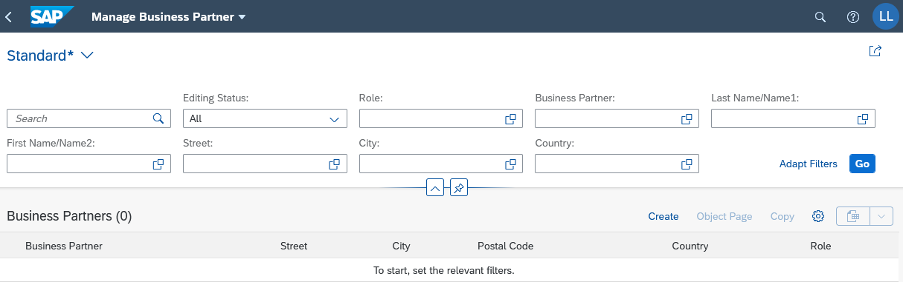
On the Manage Business Partner screen, choose and Organization. |  | Organization
In the Create Organization popup window, leave the Business Partner field blank. The system will generate a unique number later. In the BP Role field, click and in the Select: BP Role window, select FI Vendor (FLVN00). |  | FLVN00
For the Organization Title field, select Company and enter Mid-West Supply ### as the Name 1. Compare your entries with the following screenshot. |  | Company  Mid-West Supply ###
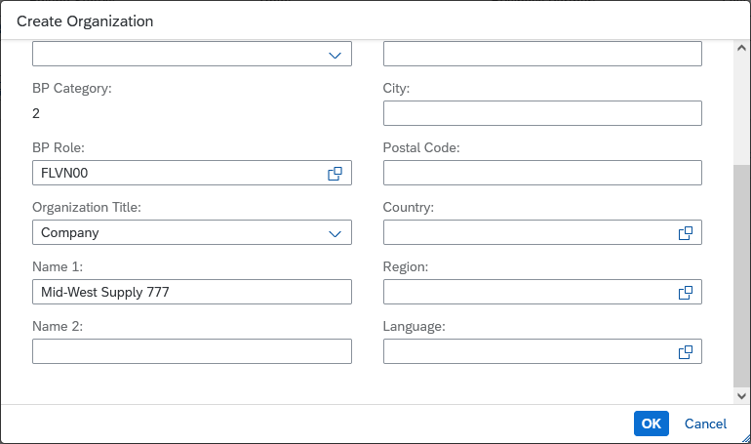
Click . In the Business Partner view, in the Basic Data area, enter your three-digit number (###) as Search Term 1. |  | ###
Go to the Address area and in the Street field, enter 335 W Industrial Lake Dr, for Postal Code 68528, for City, enter Lincoln, for Country US and Region NE. Under Standard Communication, select English (EN) as the language. Compare your entries with the following screenshot. |  | 335 W Industrial Lake  Dr  68528 Lincoln  US  NE  English
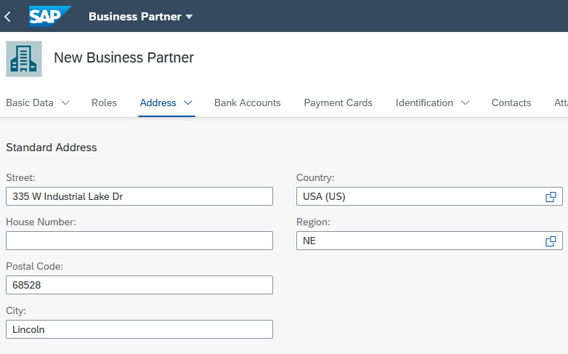
Go to the Identification tab and click in the Tax Numbers section. In the line that appears, enter US1 as the Tax Category and 12-3456### as the Tax Number – replace ### with your number. |  | US1  12-3456###
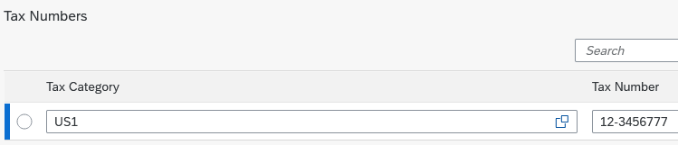
Now go back to the Roles area and click. Choose Vendor (FLVN01) as the Business Partner Role. |  | FLVN01
Now click in the row of the newly created business partner role.
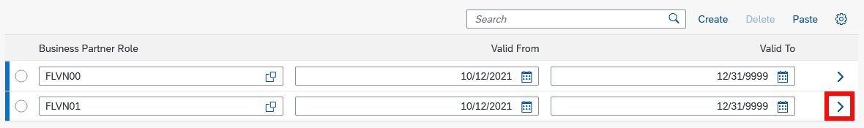
You can now maintain company code-specific data for your business partner in the role of the vendor. Go to the Company Codes area and click .
On the Company Code screen, enter US00 in the Company Code field. Select the value in the selection help that appears automatically. Confirm with Enter. |  | US00
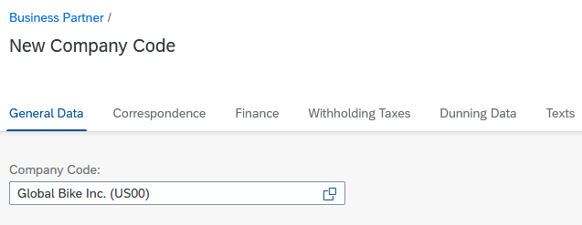
Switch to the Finance area and enter 3300000 (Trade payables) for the Reconciliation Account. In the Payment Data section, enter 0001 (Payable immediately Due net) as the Payment Terms and select Check Double Invoice. Compare your entries with the following screenshot. |  | 3300000  0001  Check Duplicate Invoice
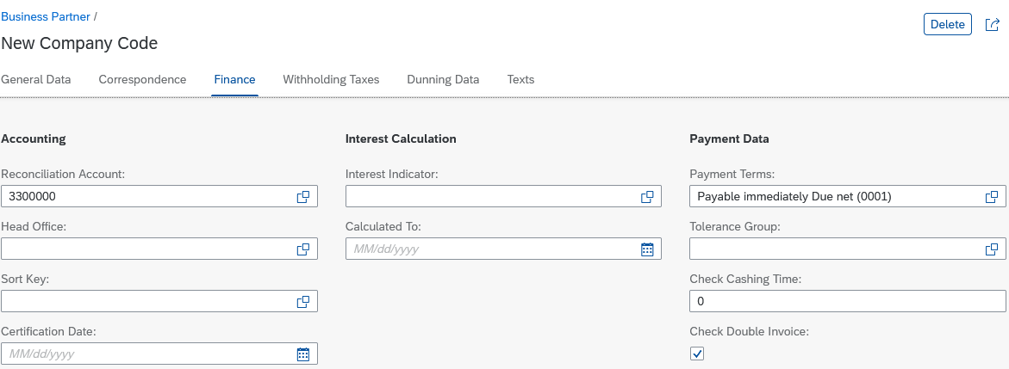
Now switch to the Correspondence area. Enter your user (LEARN-###) as the Clerk ID at Supplier. Now click in the lower screen area. |  | Your User
Back on the Supplier screen, go to the Purchasing Organizations area to enhance your Mid-West Supply business partner with purchasing-specific data.
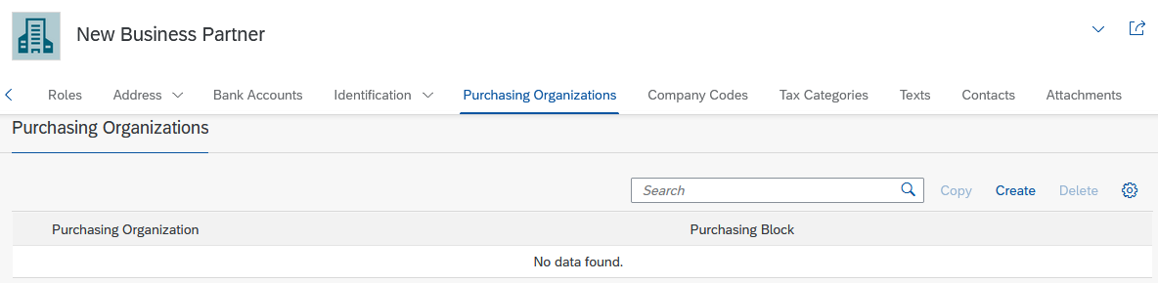
Click in the Purchasing Organization window. In the Purchasing Organization field, enter US00.
On the Purchasing Organizations area, enter USD as the Order Currency and use the F4 help to search for the Payment Terms Payable immediately Due net (0001). |  | USD  Payable immediately Due net (0001)
Navigate to the Partner Functions area. Click on and enter the partner function VN for vendor and press Enter. |  | VN
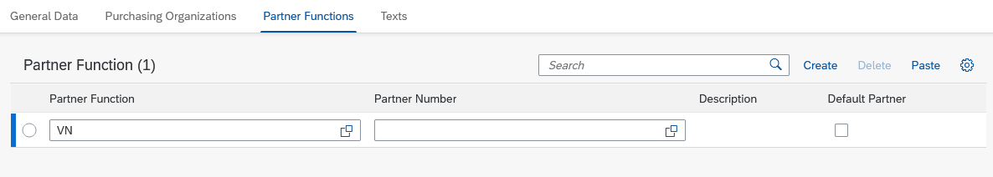
Click to transfer your purchasing-specific data for your business partner. Then click and then . The system automatically assigns a unique number to your supplier.
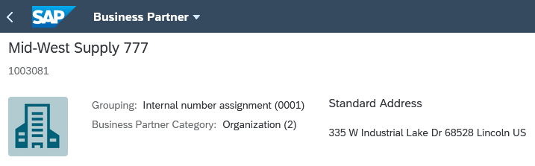
Click on the home icon  to go to the Fiori Launchpad Overview.

 | Step 2: Create Material
Task Create the material master record for a trading good.  Description Use the SAP Fiori launchpad to create the wholesale chain lock master data.  Name (position) Sandeep Die (Warehouse Supervisor) |  | Time 20 min
To create materials, go to the Materials Management space. In the Warehouse Supervisor section, you can use the Manage Product Master Data app. |  | Start
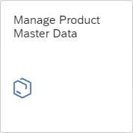
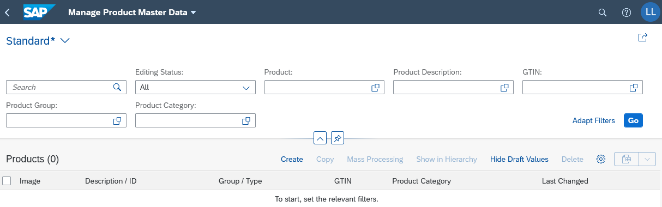
On the Manage Product Master Data screen, click .
In the Create Master Data Record dialog box that appears, enter CHLK1### as the Product Number and HAWA (Trading Goods) as the Product Type. Enter EA (Each) as the base unit of measure for the Product Group UTIL (Utilities). |  | CHLK1###  HAWA  EA  UTIL
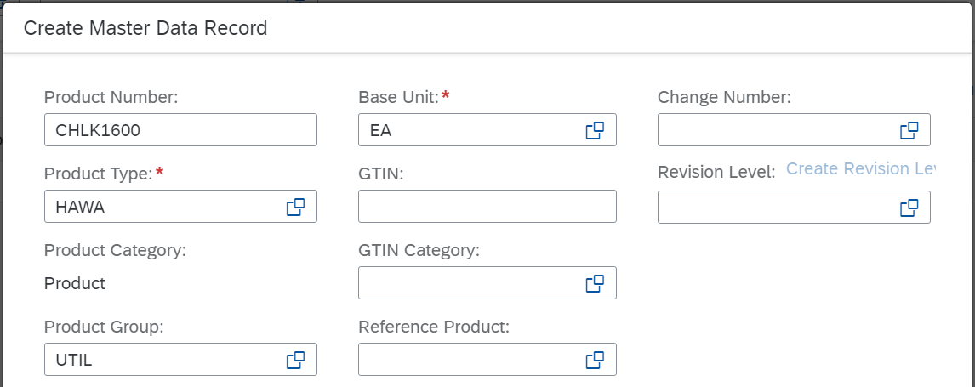
Press . In the General Information area in the Basic Data section, enter Accessories (AS) for the Division. |  | Accessories (AS)
In the Descriptions section, click . In the automatically added line, enter the Product Chain Lock ### for Language EN (English). Repeat this step and this time for Language DE (German), enter Kettenschloss ### as the Product. For both, replace ### with your number. Confirm your entries with Enter. |  | Chain Lock ###  Kettenschloss ###
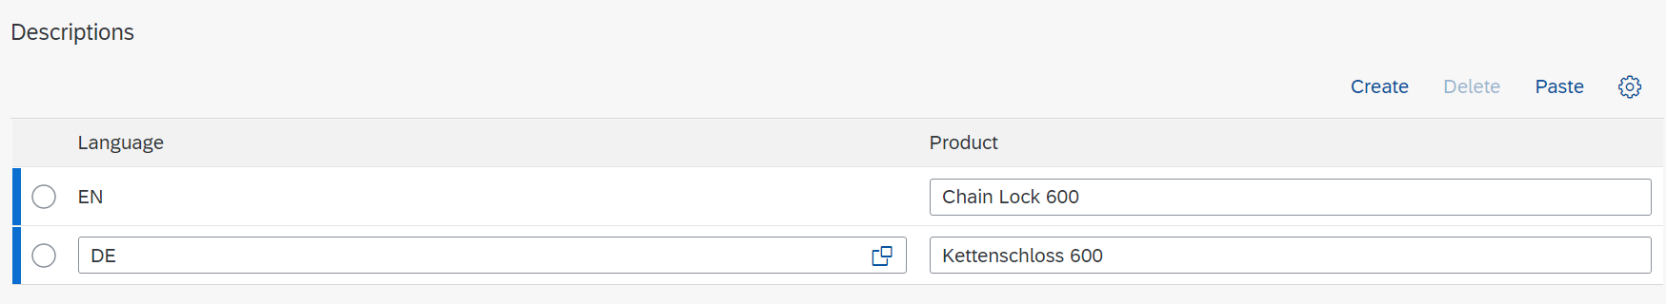
Scroll down to the Units of Measure section. At the end of the line in which the unit of measure EA is already entered, click .
On the Unit of Measure screen, in the Dimensions area, enter 65.00 for the Gross Weight and OZ (ounce) as the Unit. |  | 65.00  OZ
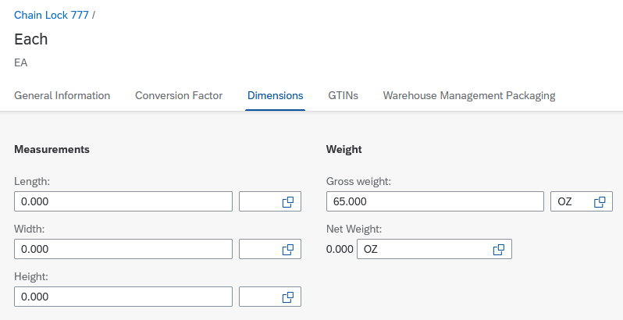
Click .
Now go to the Sales area and enter 0001 (On pallets) as the Transportation Group. Afterwards, navigate to the Distribution Chains area and choose . |  | 0001
On the Distribution Chain screen, enter Sales Organization UE00 (US East), Distribution Channel WH (Wholesale), and Delivery Plant MI00 (DC Miami). |  | UE00  WH  MI00
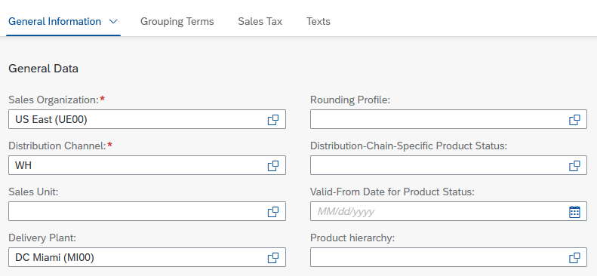
In the Grouping Terms area, choose 0001 (Make-to-order) for the Item Category Group. Choose Enter. |  | 0001
Go to the Sales Tax area and choose Tax Classification 0 (Exempt) for all three tax categories. |  | 0 (Exempt)
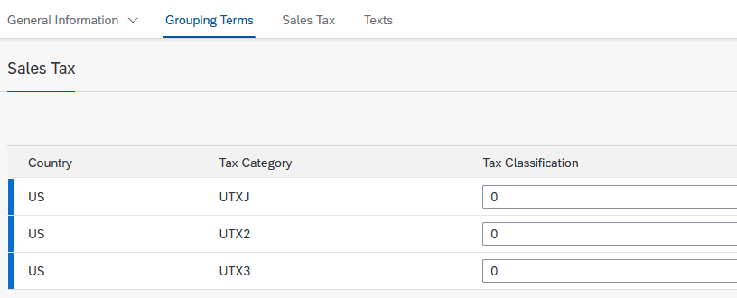
Click .
Back on the Product screen, navigate to the Plants area and click . On the Plant screen, in the General Data section, enter MI00 (DC Miami) for Plant and Hand lift for Loading Group. |  | MI00  Hand lift
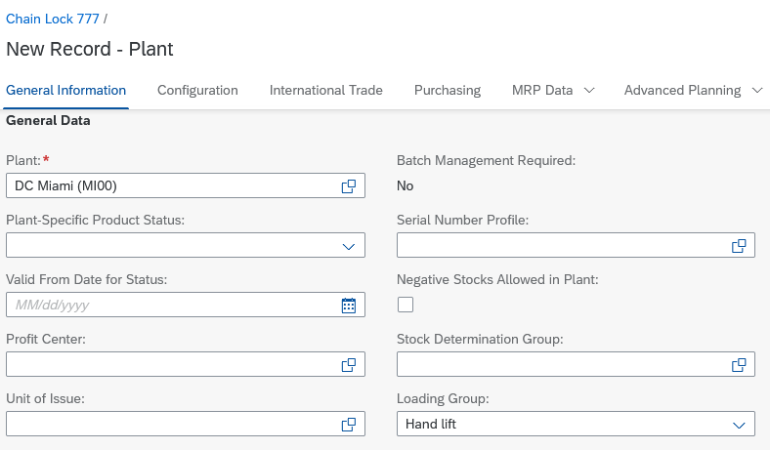
Now go to the Purchasing area and enter N00 (North America) as the Purchasing Group. |  | N00
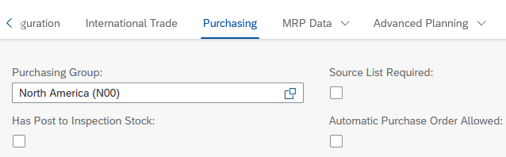
Go to the MRP Data area and enter the MRP Type PD (MRP), the MRP Controller 000 (MI MRP Controller), and the Availability Check 02 (Individual Requirement). |  | PD  000  02
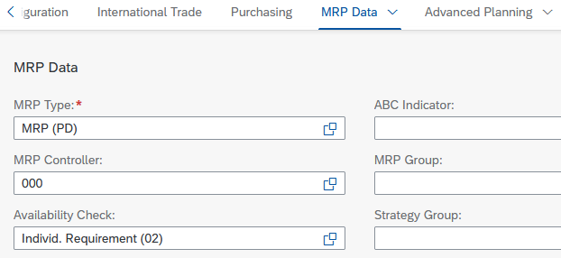
In the Lot-Size Data section, enter EX (Lot-for-lot order quantity) as the Lot-Sizing Procedure and 10 as the Minimum Lot Size. |  | EX  10
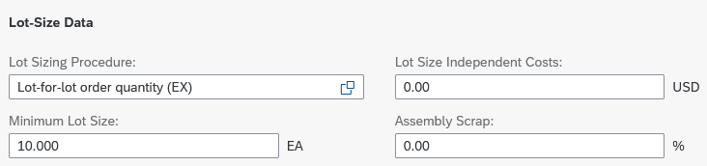
Note Some values in this view have three decimal places. Therefore, a minimum lot size of 10 is displayed as 10.000.
In the Procurement section, for Planned Delivery Time, enter 6 (days). |  | 6
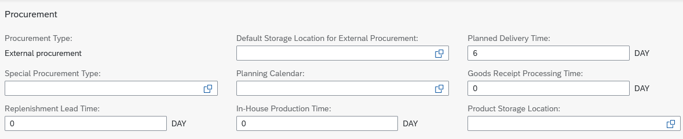
Switch to the Storage Locations area and choose .
On the Plant – Storage Location screen, enter TG00 (Trading Goods) for the Storage Location field. Click . |  | TG00
On the Product screen, please navigate to the Valuation Areas area and click . On the Valuation Area screen, enter Valuation Area MI00 and Valuation Class 3100 (Trading goods). |  | MI00  3100
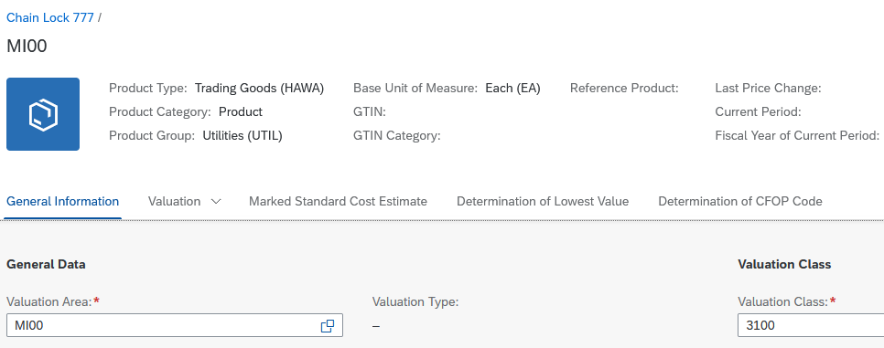
Go to the Valuation area and enter 33.50 USD as the Inventory Price and ensure that Moving Average Price/Periodic Unit Price (V) is selected for Price Control. |  | 33.50
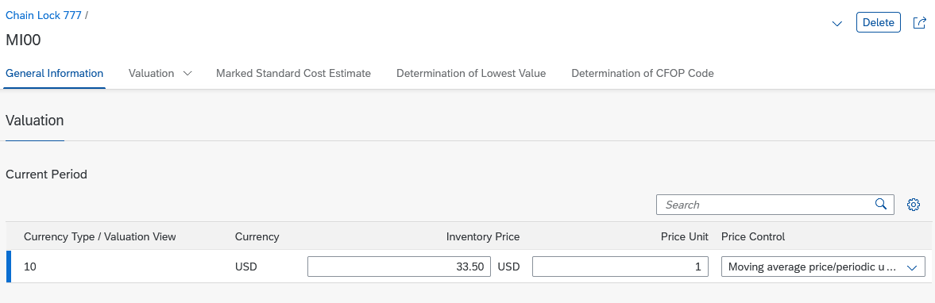
Click and then click . Your material has now been created.
Click on the home icon to go to the Fiori Launchpad Overview.

 | Step 3: Change Material
Task Extend a material master record.  Description Extend the distribution chain of the new trading goods (chain closure) to enable the San Diego plant to maintain another condition.  Name (position) Sergey Petrov (Warehouse Employee) |  | Time 5 min
To create new views for a trading good, please go to the Materials Management space. In the Warehouse Employee section, you can use the Manage Product Master Data app. |  | Start
Enter your material number CHLK1### (replace ### with your number) in the Product field and click . |  | CHLK1###
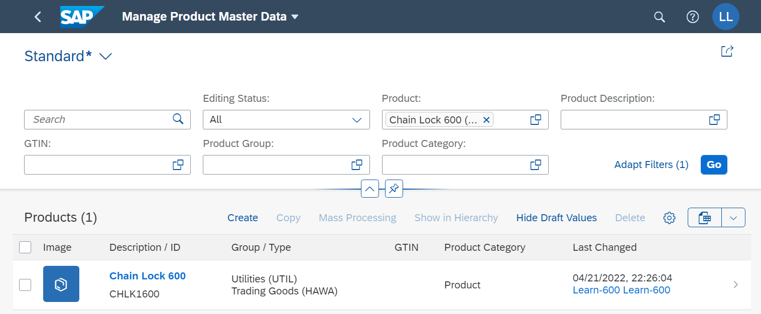
Click on the line with your material.
On the Product screen, click . Navigate to the Distribution Chains area and click .
On the Distribution Chain screen, in the General Information section, enter Sales Organization UW00 (US West), Distribution Channel WH (Wholesale), and Delivery Plant SD00 (San Diego).  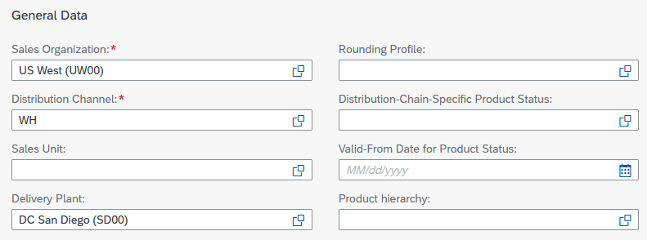 |  | UW00  WH  SD00
In the Grouping Terms area, choose 0001 (Make-to-order) for the Item Category Group. |  | 0001
In the Sales Tax area, ensure that Tax Classification 0 (Exempt) is entered for all three tax categories. |  | 0 (Exempt)
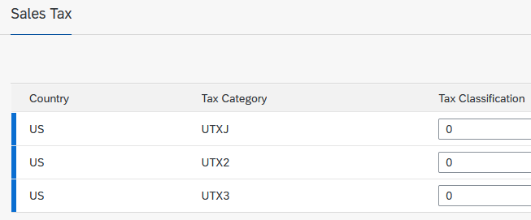
Click and then click .
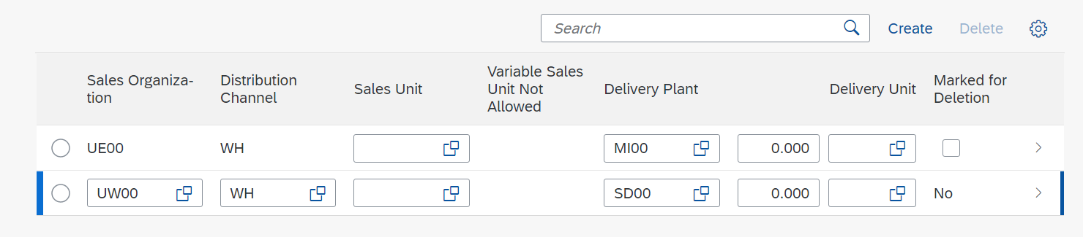
Finally, press to get to the Fiori Launchpad Overview.

 | Step 4: Display Stock
Task Display the current stock.  Description View the current stock for your chain lock and the demand for this product. The report should show that there is no provision for this and therefore no lock is currently available.  Name (position) Wilton Saban (Inventory Supervisor) |  | Time 5 min
The stock is dynamic. As a result, it always changes when the affected material is used in a transaction. |  | Stock
To display the stock, go to the Materials Management space. In the Inventory Supervisor section, you can use the Stock - Single Material app. |  | Start
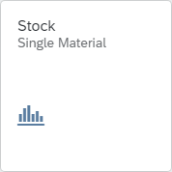
You will be directed to the following screen.
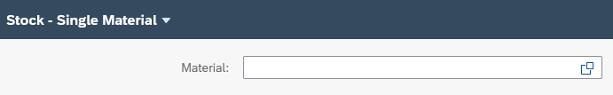
To find the material number of your chain lock, click in the Material field and then click . In the Material field, enter your number in the format *###. Click to search. Double-click your material CHLK1###. Your stock should look like this: |  | *###
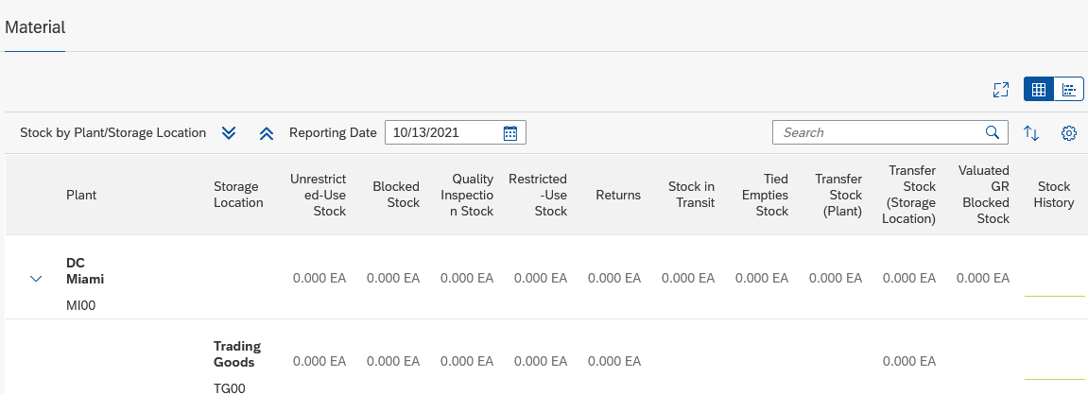
In the DC Miami row, in the Stock History column, click theicon. The system will now display the stock history of your material CHLK1### in DC Miami.
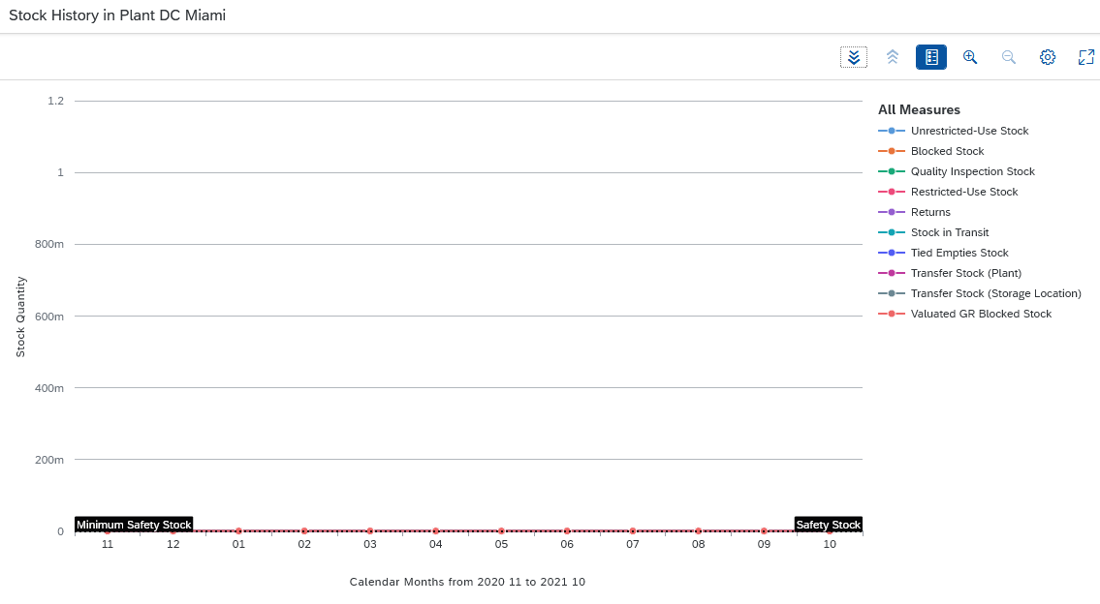
Note Since the material has just been created and no stocks have been posted yet, the stock history in all key figures is 0.
Close the window and click the Home button to return to the SAP Fiori launchpad.

 | Step 5: Create Purchase Requisition
Task Create a purchase requisition.  Description The sales management has informed the purchasing department that an advertising campaign is starting in 3 months to introduce the new chain lock. Create a demand (purchase requisition) for 200 of your locks so that you can choose the supplier that best meets your needs from any quotations.  Name (position) Wilton Saban (Inventory Supervisor) |  | Time 5 min
To create a purchase requisition, please go to the Materials Management space. In the Inventory Supervisor section, you can use the Create Purchase Requisition app. |  | Start
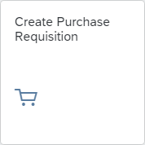
You should now see the following screen.
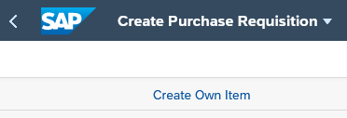
Click .
Enter Material CHLK1### (## - replace with your number), press Enter. The Short Tex and Material Group will be added automatically. |  | CHLK1###
Enter 32.00 USD as the Valuation Price, 1 as the Price Unit, and 200 as the Quantity Requested. For the Delivery Date, you choose today in 3 months. |  | 32.00 USD  1  200  Today in 3 months
Note The requested quantity is displayed with three decimal places. Therefore, your 200 is displayed as 200.000.
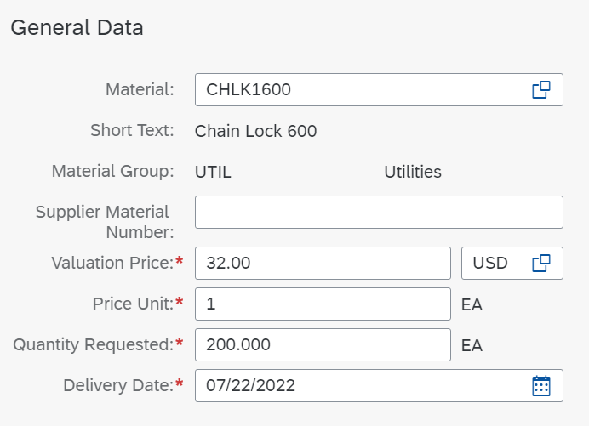
At the very end, enter the following message under the Notes heading and on the Item text tab page:
“Global Bike formally requests quotations for the following material. Quotations will be accepted until [01. day of next month].“
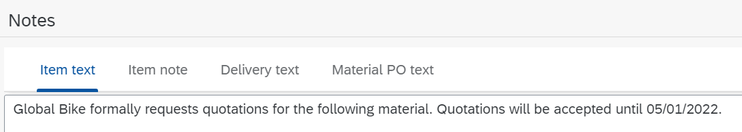
Click . In the upper right corner, you can see the item in the shopping cart.
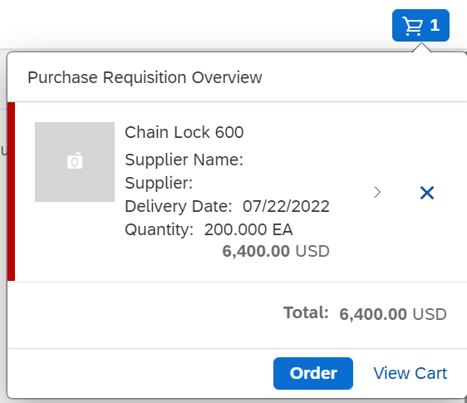
Click to view your requisition.
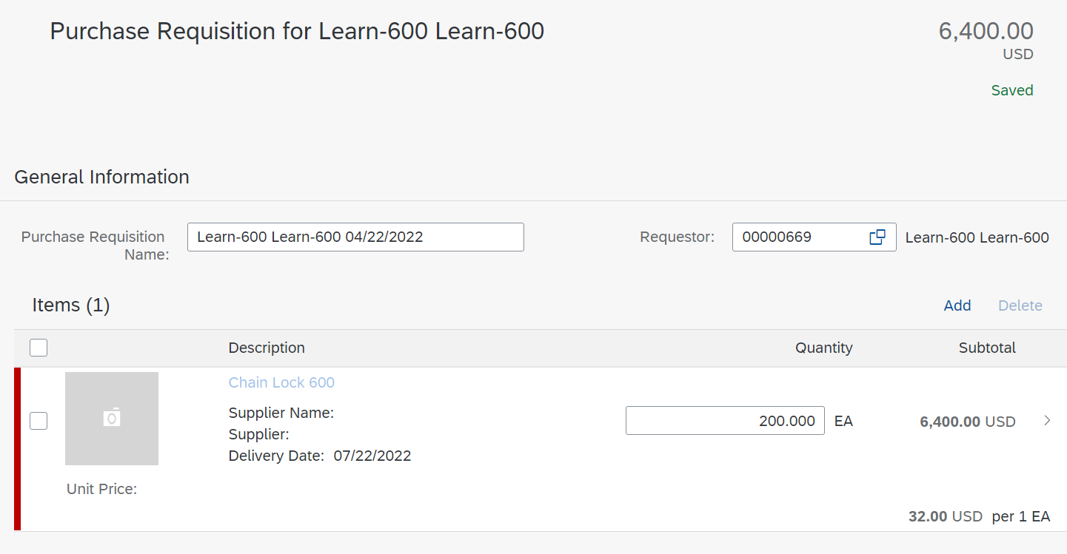
In the Items area, click on the line of the chain lock to add some details.
In the Item Details view, enter N00 as the Purchasing Group, US00 as the Purchasing Organization, US00 as the Company Code, and MI00 as the Plant. |  | N00  US00  US00  MI00
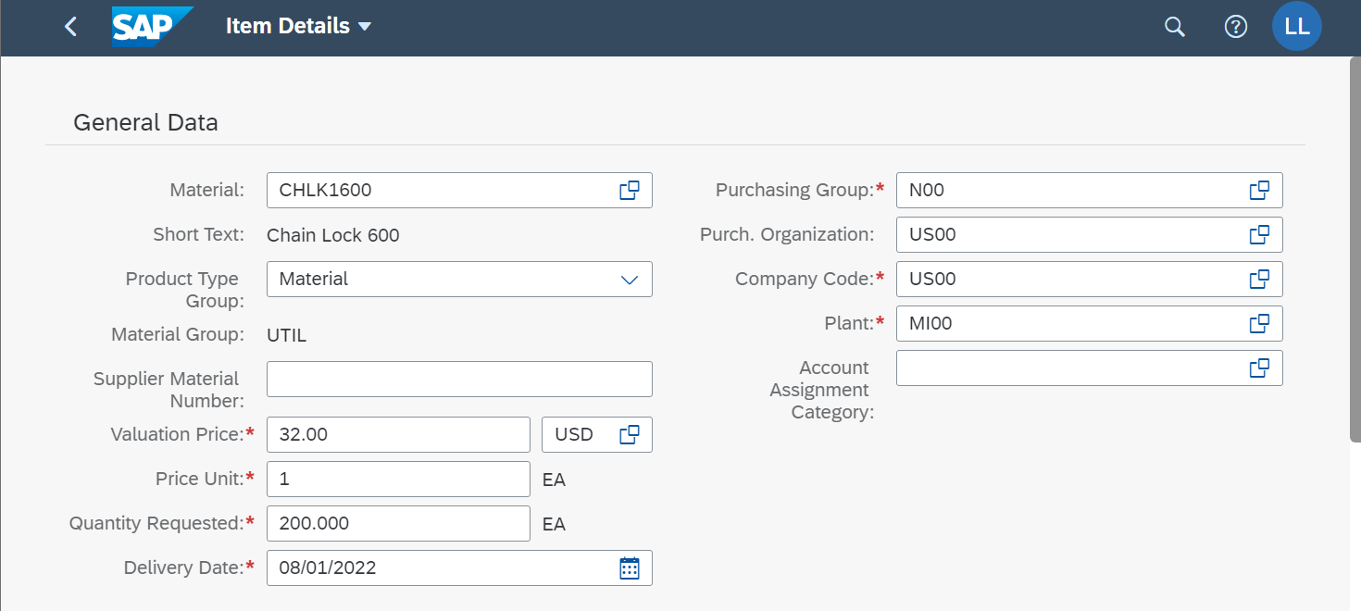
Click . Afterwards, click and then choose to confirm the request. The system creates a separate document number.
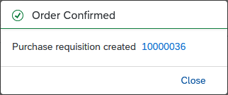
Close the notification and then click to go to the SAP Fiori launchpad.

 | Step 6: Manage Stock
Task Manage the stock.  Description Display the stock/requirements list of your existing chain lock and check which requirements exist for this product.  Name (position) Alberto Conti (Inventory Assistant) |  | Time 5 min
Please go to the Materials Management space. In the Inventory Assistant section, you can use the Stock (Single Material) app to display the stock/requirements list. |  | Start
On the Stock – Single Material screen, in the Material field, enter your chain lock CHLK1###. Your warehouse/demand list should look similar to the screenshot below. |  | CHLK1###
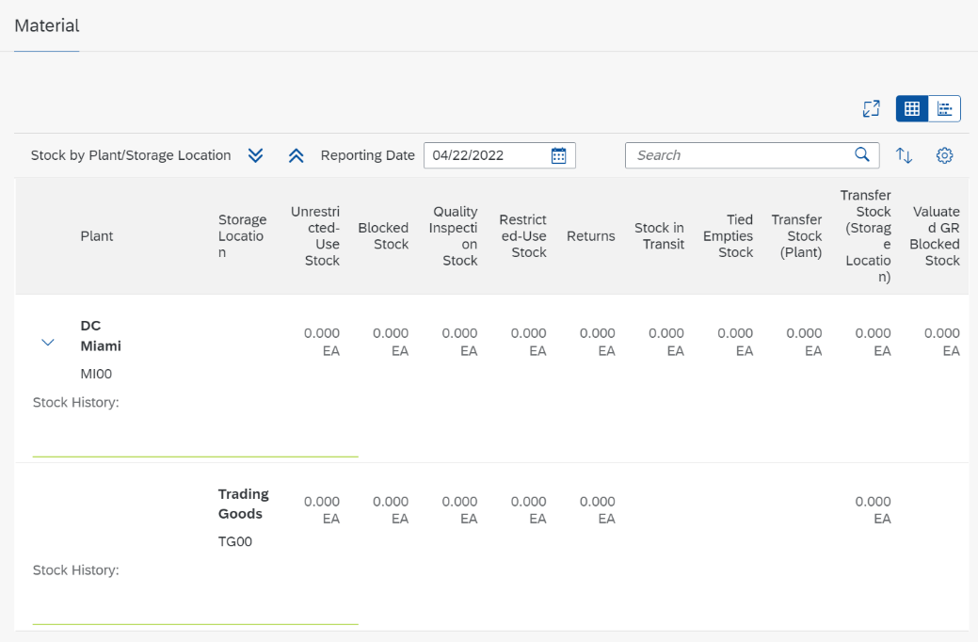
In the DC Miami row, in the Stock History column, click the icon .
The system will now display the stock history of your material CHLK1### in DC Miami.
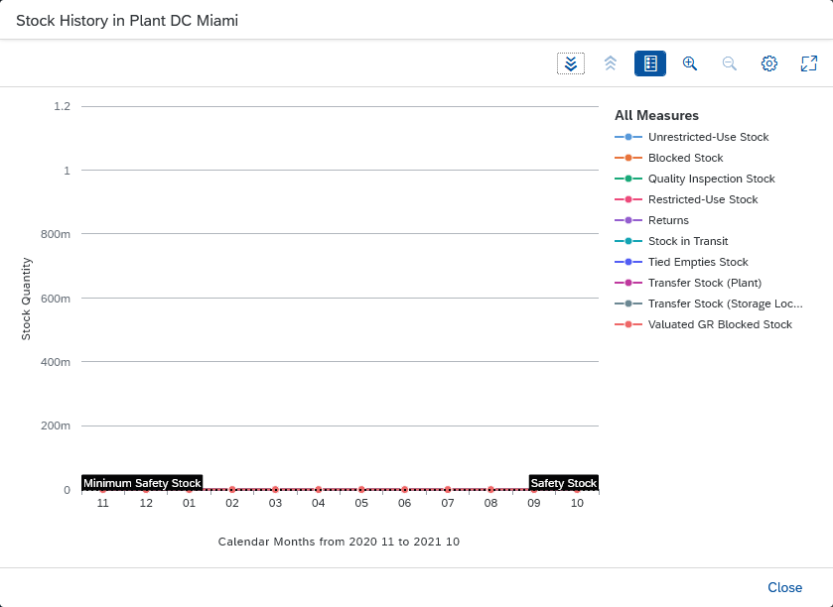
Note As you can see, the creation of the purchase requisition has not influenced the stock development.
Click to go to the SAP Fiori launchpad

 | Step 7: Create RFQ
Task Create a request for quotation for your purchase requisition.  Description Create one request for each supplier. This is used to collect all relevant information (such as pricing, delivery, and so on) that is needed to select the supplier that best meets your requirements.  Name (position) Aura Maxwell (Purchasing Agent) |  | Time 5 min
To create a request for quotation for your purchase requisition, go to the Materials Management space. In the Purchasing Agent section, you can use the Manage Purchase Requisitions app |  | Start
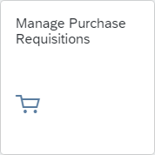
In the Search field enter you material CHLK1### and click . |  | CHLK1###
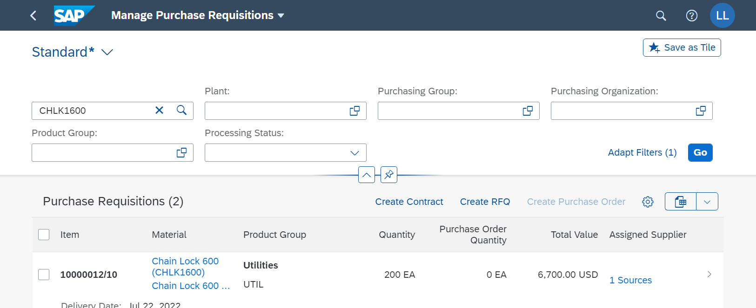
Select the row with your Purchase Requisition and click .
In the Manage Purchase Requisitions screen enter Request for Quote as RFQ Type, RFQ1### as RFQ Description, one month from today as the Quotation Deadline, US00 for the Purchasing Organization and Company Code. |  | Request for Quote  RFQ1###  One month from today  US00  US00
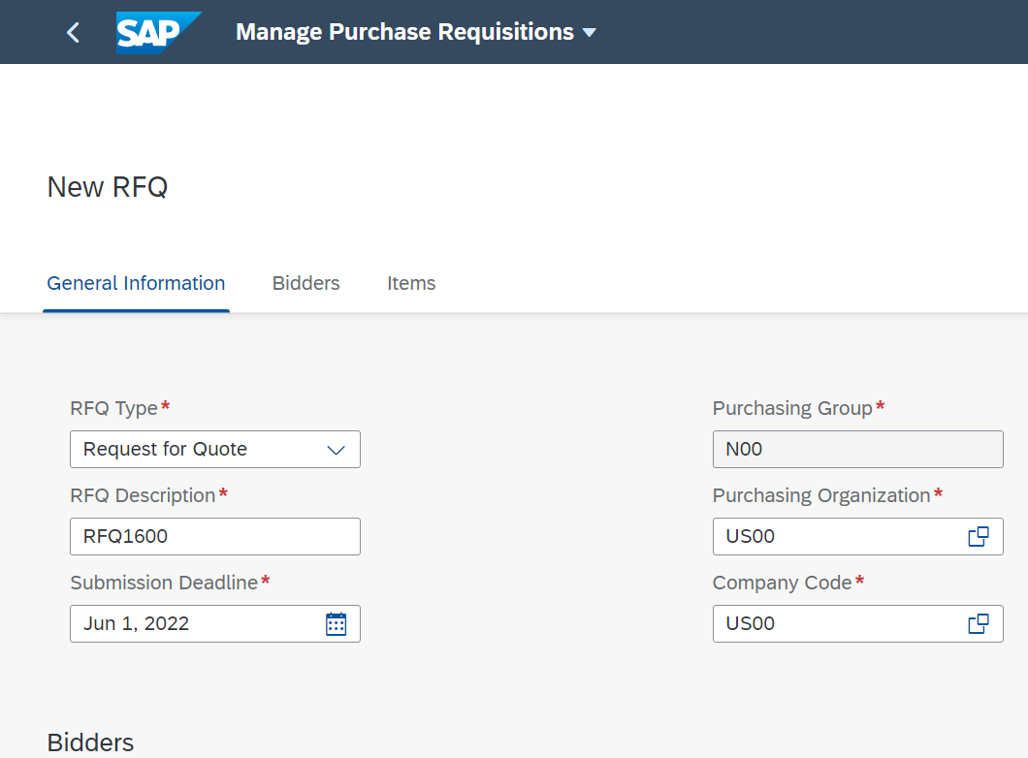
In the Bidders area click on to add a new bidder.
Search for your supplier Mid-West Supply ###. Select the entry with your supplier and click  to add them as bidder. |  | Mid-West Supply ###
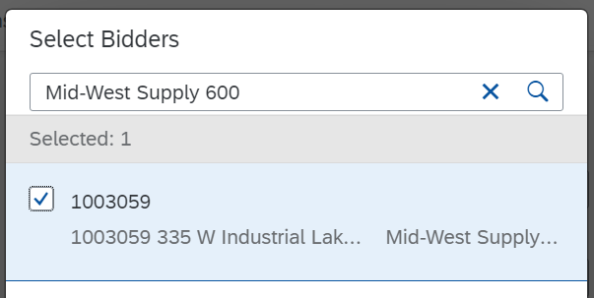
Repeat this procedure to add the suppliers Dallas Bike Basics and Spy Gear as bidders. |  | Dallas Bike Basic  Spy Gear
Note You recognize your supplier by the last three digits of the supplier number. For example, supplier number 103000 represents supplier Dallas Bike Basics for user LEARN-000.
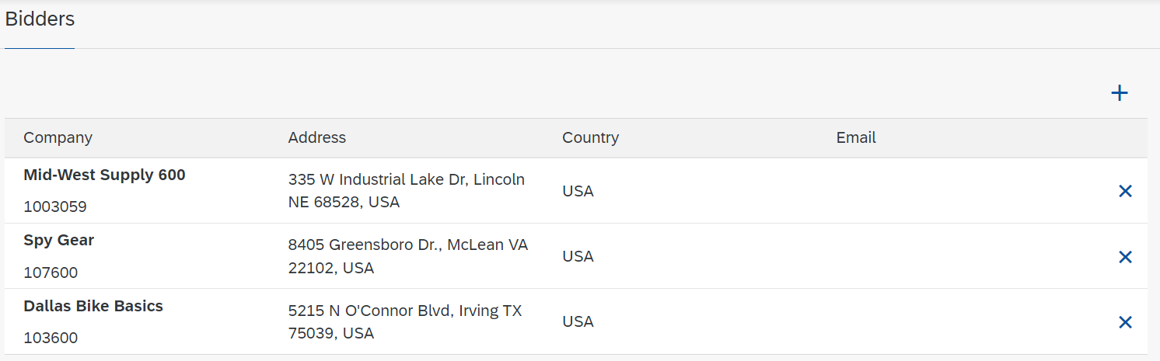
Note that in the Items section your purchase requisition was added.
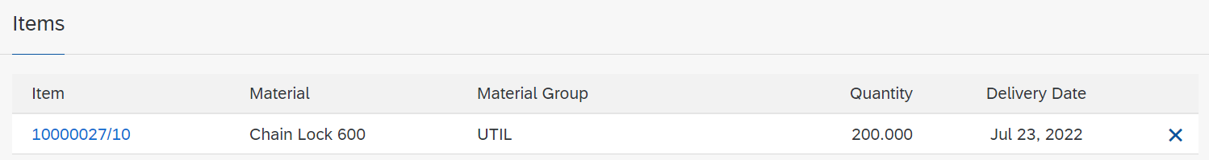
Click  and confirm the pop up with .
You will get a success message.
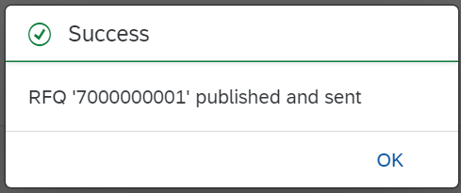
Close the pop up and click to go to the SAP Fiori launchpad.

 | Step 8: Create Quotation from Vendor
Task Maintain the quotation from a supplier.  Description After we receiving responses to our purchase requisition from our suppliers, it is necessary to maintain the respective information in our procurement system in order to create comparability with which we can support the choice of supplier.  Name (position) Alberto Conti (Inventory Assistant) |  | Time 10 min
Go to the Materials Management space. In the Inventory Assistant section, you can use the Manage RFQs app to create a request for quotation for your purchase requisition. If the app is missing in this section, please search it with the help of the search bar in the upper screen area. |  | Start
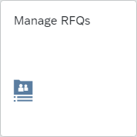
In the Search field enter RFQ1### and click . |  | RFQ1###
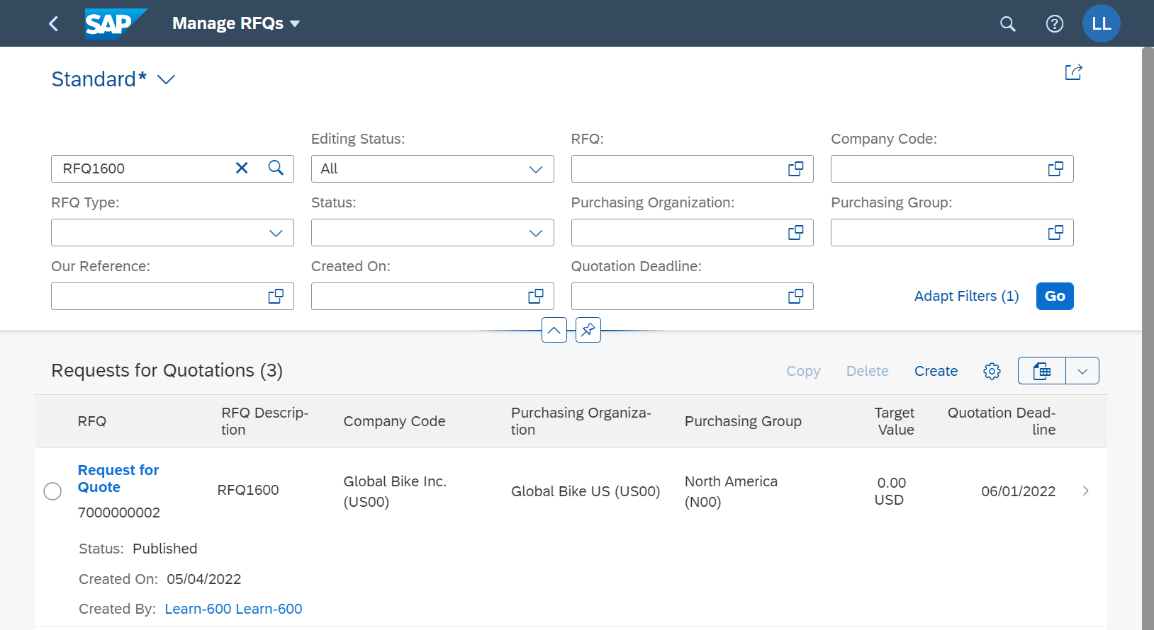
Click on the row with your Request for Quote. Go to the Bidder area. Select your bidder Mid-West Supply ### and click 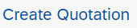 to create a quotation.
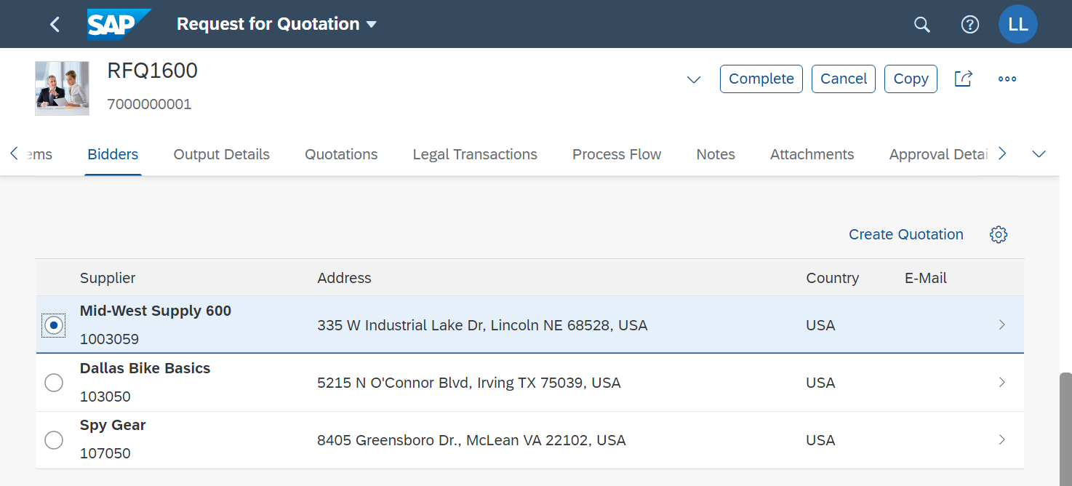
In the Supplier Quotation window enter three weeks from today as Quotation Submission Date. |  | Three weeks from today
Note The submission date must not be after the end of the bid period. You can find the quotation deadline unter general Information.
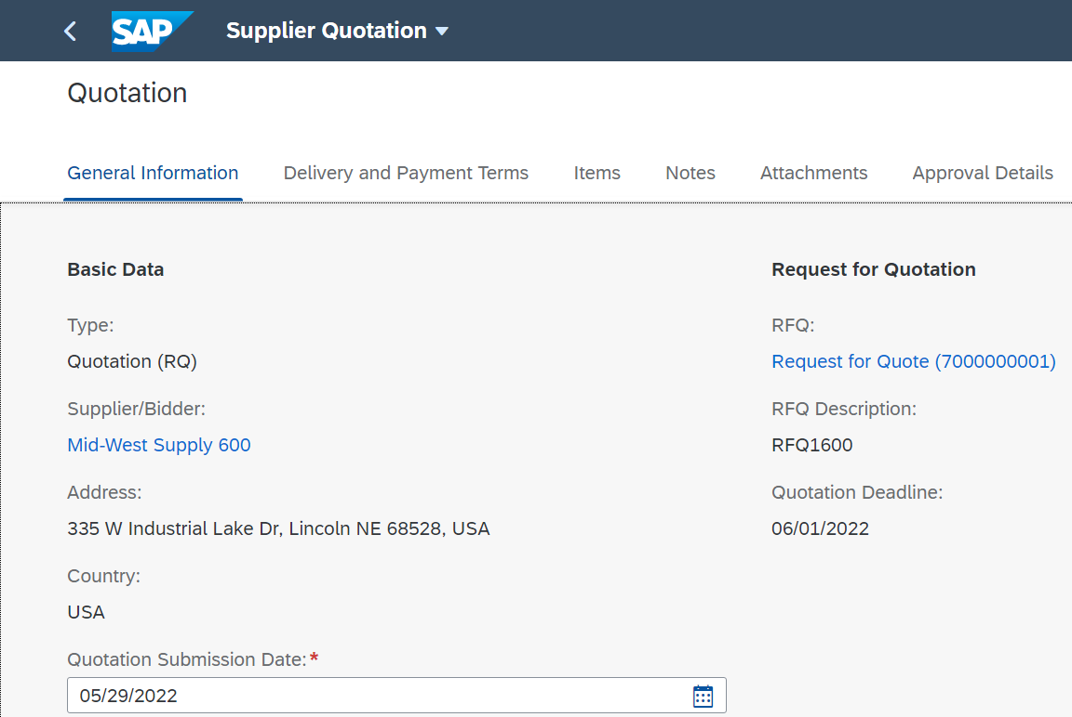
In the Items are enter 32.00 USD as Net Order Price. |  | 32.00
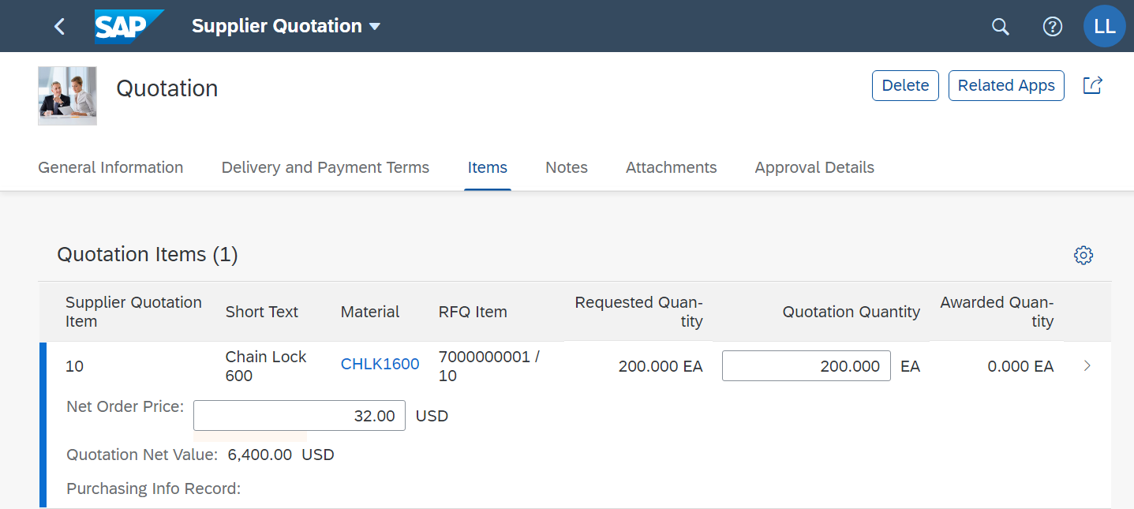
Click  to create the Quotation. Click 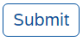 to submit the Quotation. If you don't see the Submit button, enlarge your browser window.
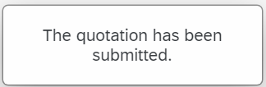
Click to return to the Request for Quotation window. The quotation from your supplier Mid-West Supply ### can now be found in the Quotations area.
Repeat this process for the other two bidders. Enter the following prices:  Dallas Bike Basics 36.50 USD  Spy Gear 35.00 USD  Make sure you save both requests and take note of the success messages. |  | Dallas Bike Basics  36.50  Spy Gear  35.00
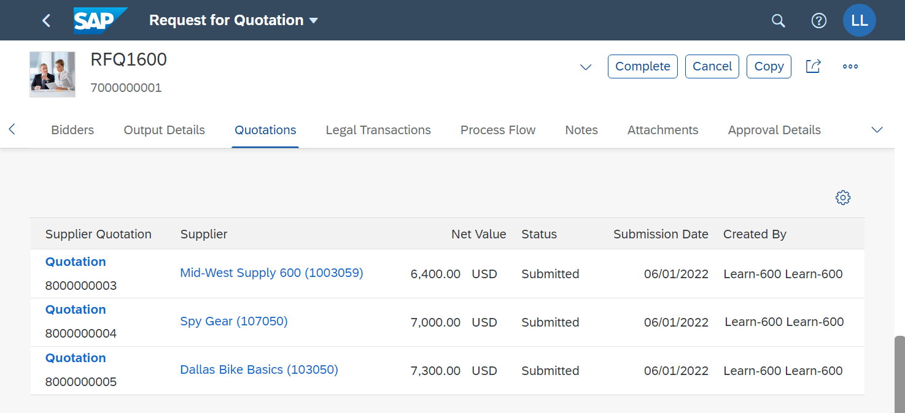
Click to go to the SAP Fiori launchpad. Confirm any notes by choosing OK.

 | Step 9: Price Based Bid Evaluation
Task Evaluate the quotes based on the price. Reject two of the three offers.  Description Generate a quotation price comparison list from the quotations from the individual vendors. The quotation price comparison list sorts the quotations from lowest to highest.  The successful vendor (Mid-West Supply) was selected using the criterion of the most favorable quotation. It is now necessary to inform the subordinate providers of the rejection of their offers.  Name (position) Wilton Saban (Inventory Supervisor) |  | Time 5 min
Go to the Materials Management space. In the Inventory Assistant section, you can use the Compare Supplier Quotations app to reject a quotation. If the app is missing in this section, please search it with the help of the search bar in the upper screen area. |  | Start
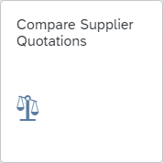
Search for your Request for Quotation by using the F4 help. Enter the RFQ1### as RFQ Description and click . |  | RFQ1###
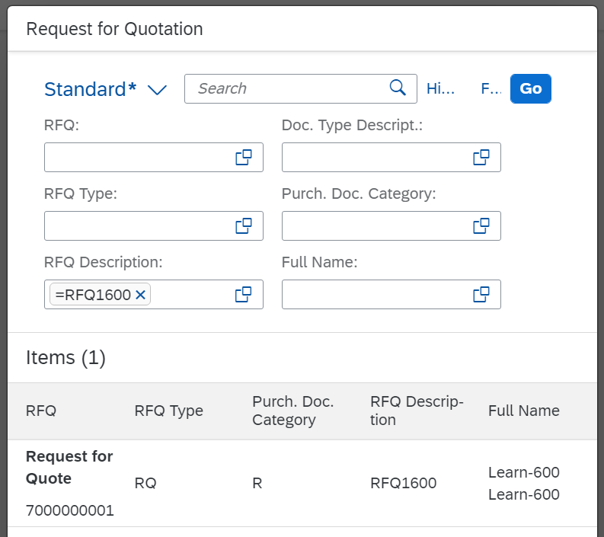
Select your RFQ.
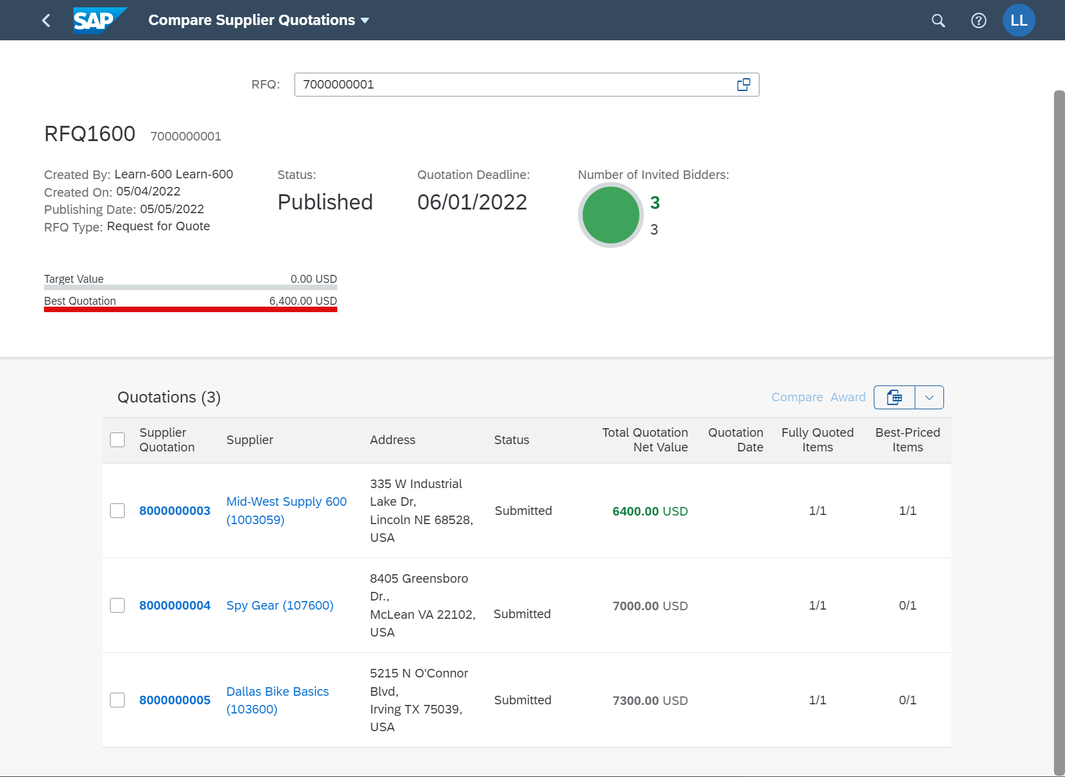
Compare the quotes and select the best one, in this case the quotation from Mid-West Supply ###. Choose the beste Quote and click .
Note For the best offer the Total Quotation Net Value is highlighted in green.
Reject the other two offers. To do this click on the Supplier Qutation number and the on Manage Supplier Quotation.
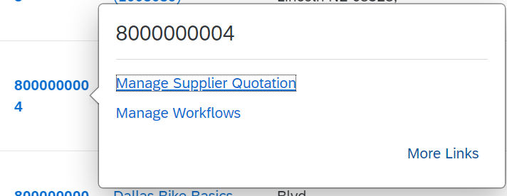
In the Supplier Quotation window click on 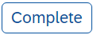 (top right).
Note If your browser window is to small, the Complete button will be hidden under 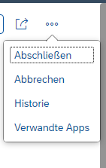.
Click to return to the Compare Supplier Quotations window.
Repeat this procedure to also reject the second quotation.
Click to go to the SAP Fiori launchpad. Confirm any notes by choosing OK.

 | Step 10: Create Purchase Order Referencing an RFQ
Task Create a purchase order with reference to a request for quotation.  Description Create a purchase order that refers to the successful supplier's quote. The details are then imported into the new purchase order.  Name (position) Aura Maxwell (Purchasing Agent) |  | Time 15 min
Go to the Materials Management space. There, you can use the Manage RFQs app to create a request for quotation for your purchase requisition. If the app is missing in this section, please search it with the help of the search bar in the upper screen area. |  | Start
In the search field enter RFQ1### and click . |  | RFQ1###
Open your RFQ and go to the Process Flow area.
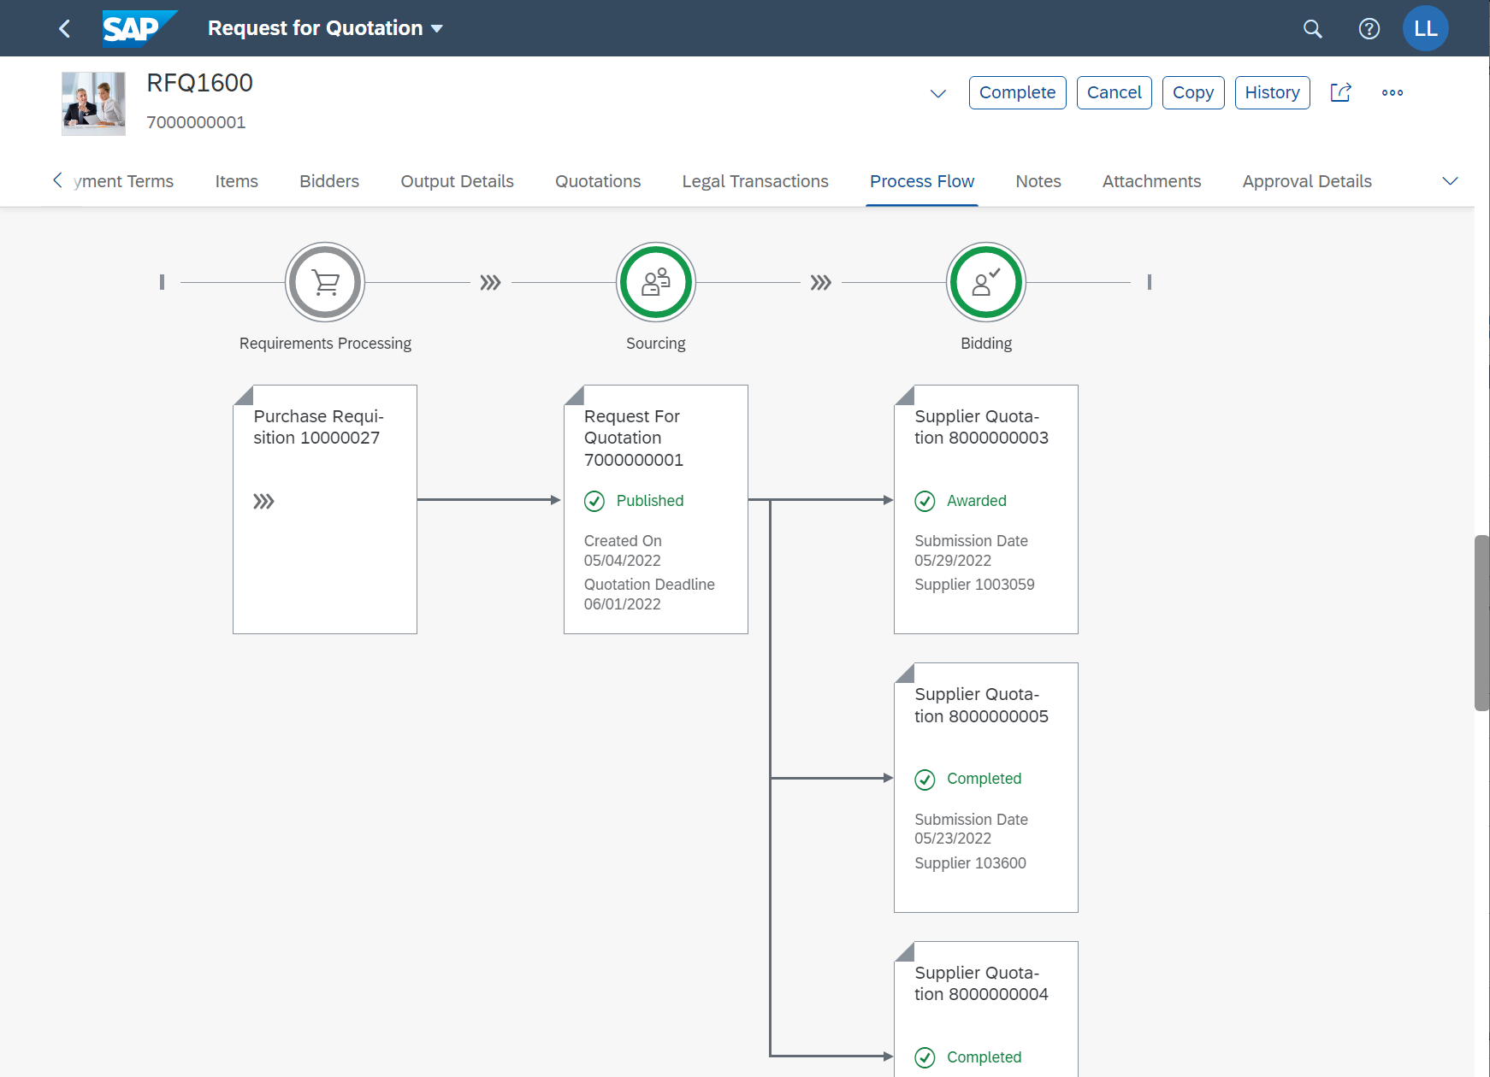
You see your purchase requisition followed by the associated RFQ and the three supplier quotations. Two of the three offers have already been rejected, as indicated by the comment completed.
Click on the Supplier Quotation with the comment 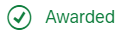 and then on .
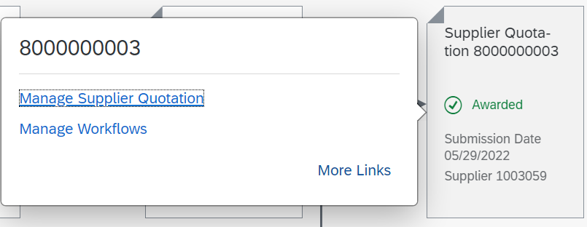
To create a purchase order from the quotation click in the Supplier Quotation window on and then on .
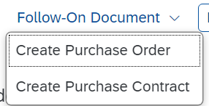
In the Purchase Order go to the Purchase Order Items area you see one entry with your CHLK1### material.
We want to split the delivery in two partial deliverys. Change the Order Quantity from 200 to 100. Select the entry and click . |  | 200 100
In the Purchase Order Item screen go to the Schedule Lines area and change the Delivery Date to one week later. |  | 1 week after 1st delivery
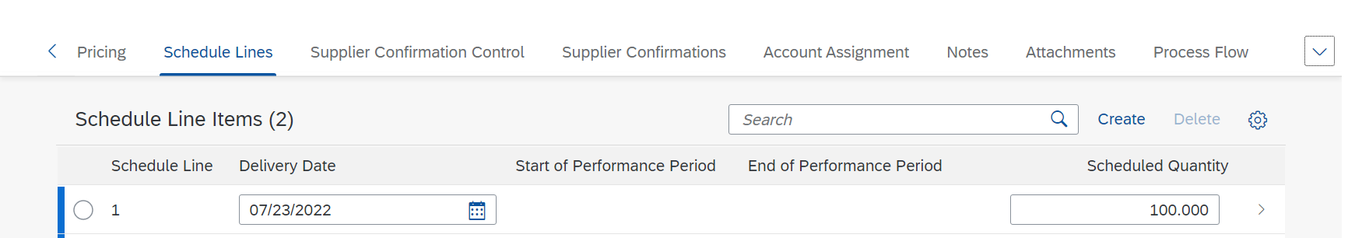
Click on .
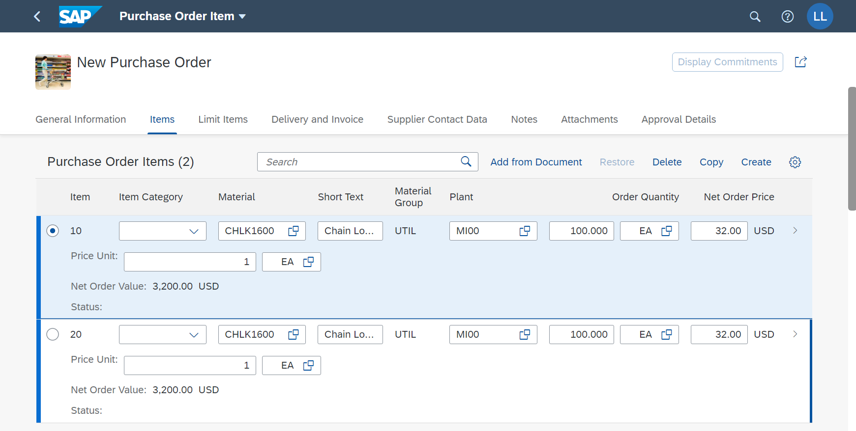
Back in the Purchase Order Item window click on .
Note A purchase order is a formal request to a vendor to deliver goods or services according to the conditions of the purchase order. Several objects can trigger a purchase order (see graphic).
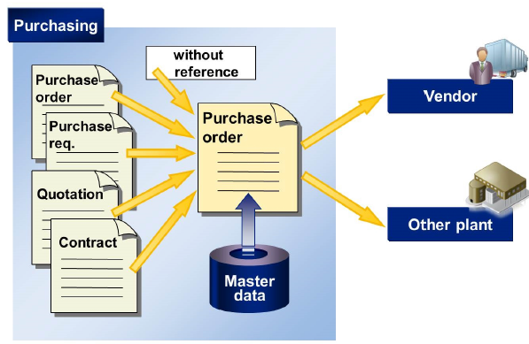
Goods receipt and invoice verification are usually based on the purchase order.
Click until you have returned to the Request for Quotation screen. Take another look at the Process Flow. The Quotation is now followed by a purchase order.
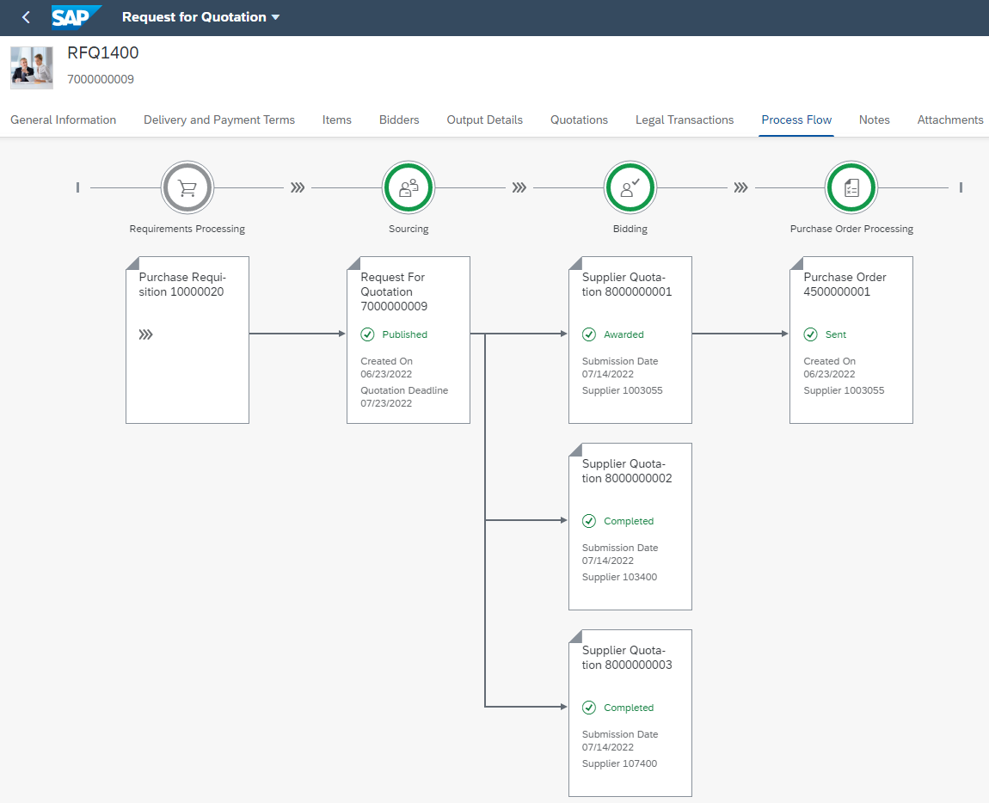
Click to go to the SAP Fiori launchpad. Confirm any notes by choosing OK.

 | Step 11: Display Purchase Order
Task Display your purchase order.  Description You now want to look in the system at what you have sent to the vendor.  Name (position) Aura Maxwell (Purchasing Agent 2) |  | Time 5 min
To display the purchase order, please go to the Materials Management space. In the Purchasing Agent section, you can use My Purchasing Document Items (Professional) app. |  | Start
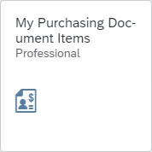
The app provides you with an overview of all purchase requisitions, purchase orders, goods receipts, and supplier invoices. In the Supplier field, enter Mid-West Supply ### and choose . |  | Mid-West Supply ###
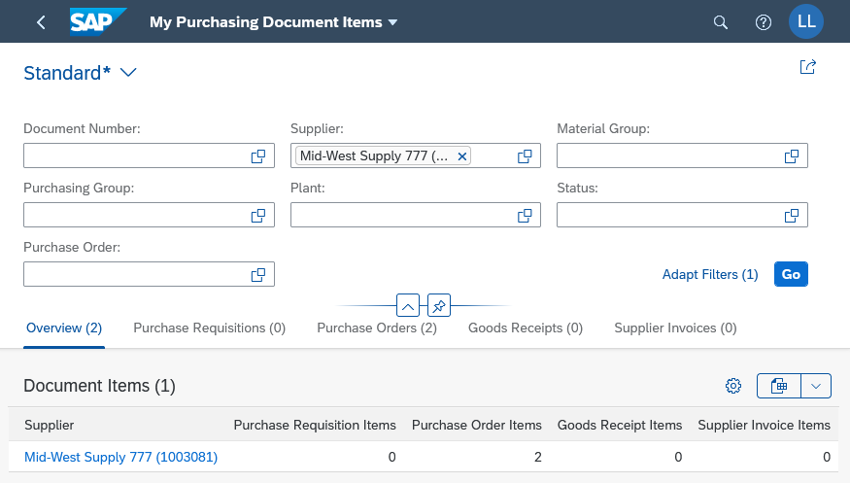
Click . The number you see may be different. You may need to scroll down to see your supplier and purchase order.
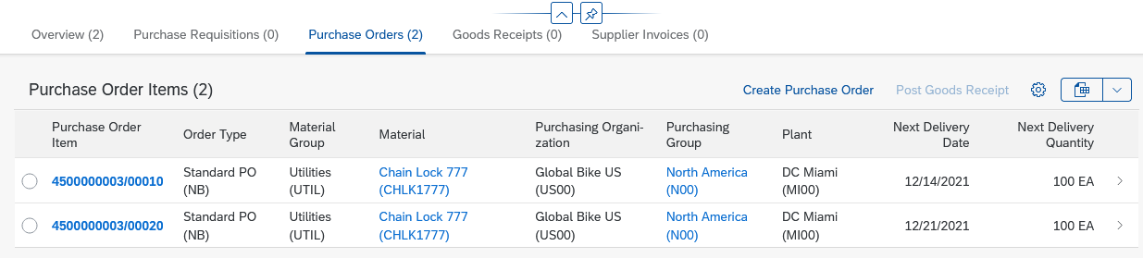
Click to go to the SAP Fiori launchpad.

 | Step 12: Post Goods Receipt for Purchase Order
Task Create a goods receipt posting for your purchase order.  Description You receive the goods that you ordered in the previous step from Mid-West Supply into your inventory. A goods receipt posting is created that refers to your purchase order. The stock is increased and a financial document is created that posts the value of the goods correctly.  Name (position) Tatiana Karsova (Goods Receipt Clerk) |  | Time 5 min
To post the goods receipt, please go to the Materials Management space. In the Goods Receipt Clerk section, you can use the Post Goods Receipt for Purchasing Document app. |  | Start
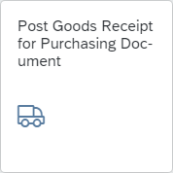
Enter your purchasing document number in the Purchasing Document field. If you want to search for your purchasing document number, use the F4 help. In the search field, enter CHLK1### and then click . |  | Your purchase order number  CHLK1###
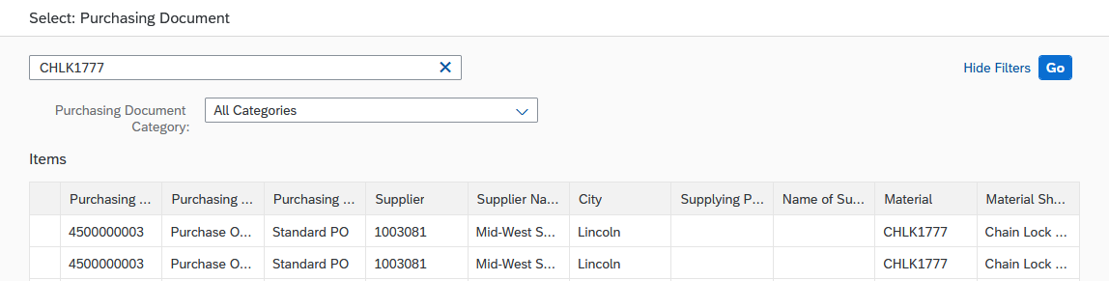
Then select the first of your purchase orders by double-clicking it. You can now see your subdivided purchase order. |  | First of your orders
Note If goods are delivered for a purchase order, document a goods receipt with reference to the purchase order. The system checks the purchase order and copies only the open purchase order items to the goods receipt transaction.
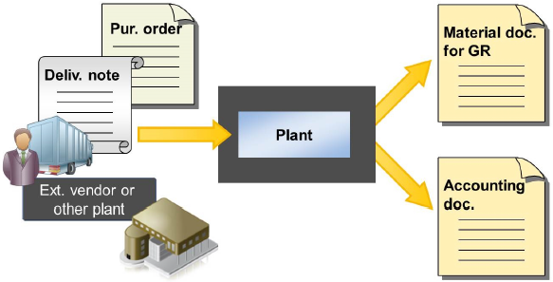
For goods receipt with reference to a purchase order, the system checks the following:
- Whether the correct material was delivered.
- Whether the correct quantity was delivered. (If there is no surplus or underdelivery)
- Whether perishable goods are within their minimum shelf life. (In this case, the shelf life expiration date check must be activated.)
For Printing, select Individual slip. If it is not filled automatically, select TG00 (Trading Goods) in the individual items for storage location. |  | Individual slip  TG00
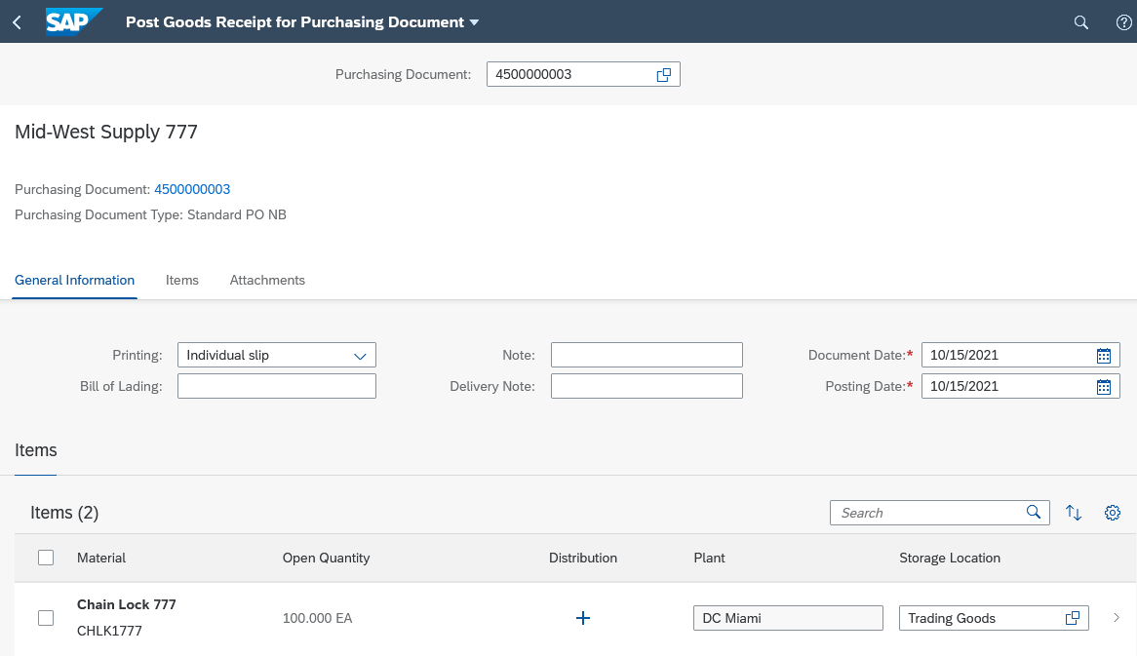
Since you have split your purchase order, you should see two lines with 100 pieces. In this step, we only process the first delivery. Therefore, click on the first row to check all entries.
Select the Delivery Completed checkbox. |  | X
Check that Tradings Goods is entered as the storage location and change the stock type to Quality Inspection. |  | Trading goods  Quality Inspection
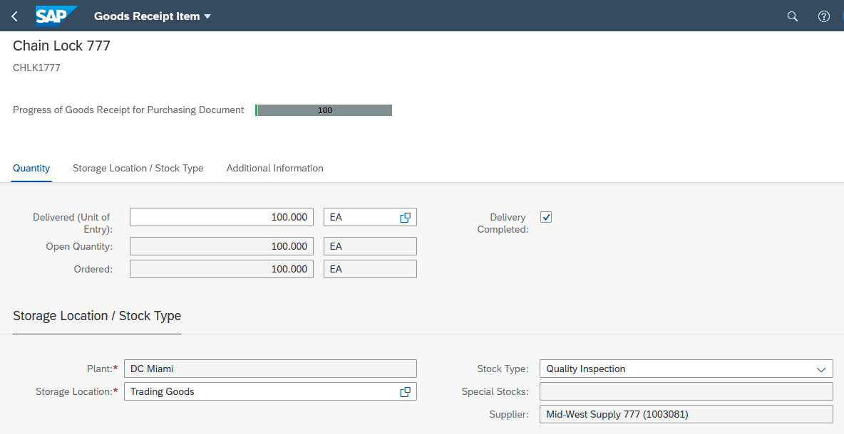
Now click .
Note Inventory Management recognizes various stock types that indicate the usability of the material:
- unrestricted-use stock
- Stock in quality inspection
- blocked stock
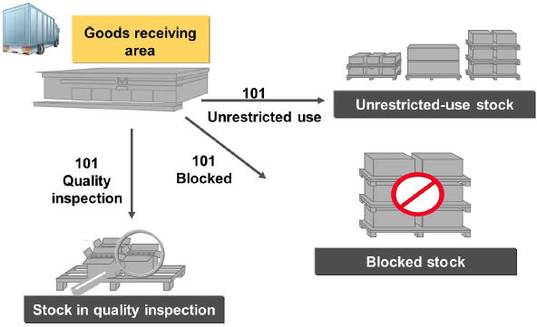
For goods receipts, you decide to which stock type a quantity is posted. The stock type is relevant for determining the available stock in material requirements planning (MRP) and for withdrawals in inventory management (see also Availability Check).
You can only post withdrawals for consumption from unrestricted-use stock. From quality inspection stock and blocked stock, you can only withdraw a sample, scrap a quantity, or post an inventory difference.
Leave the first line selected. Click Post to post the goods receipt of your material. You receive the following success message with your material document number.
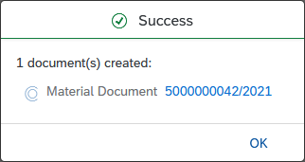
Note When you post a goods receipt into one of the warehouses, the system generates a material document. This document contains information about the delivered material and the corresponding quantity. For stock items, the plant storage location is documented.
Close the message and click to go to the SAP Fiori launchpad.

 | Step 13: Check Received Goods
Task Check the quality of the goods.  Description You must ensure that the goods have been delivered in the required quality. The goods are released for consumption.  Name (position) Sandeep Die (Warehouse Supervisor) |  | Time 5 min
Please go to the Materials Management space. In the Warehouse Supervisor section, you can use the Stock (Single Material) app to perform a quality inspection of the goods. |  | Start
If it is not already selected, enter your material CHLK1###. A list is displayed. Click your material CHLK1###. |  | CHLK1###
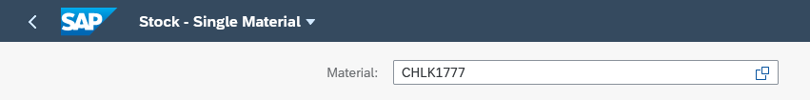
In the previous step, you posted the received goods for quality inspection. Here you can see the 100 units of quality inspection stock.
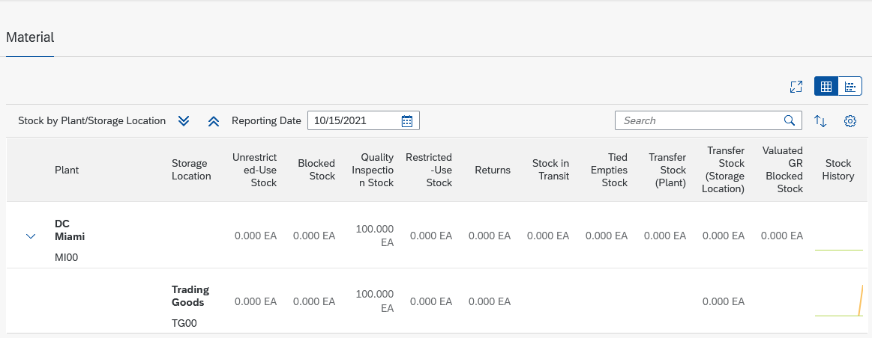
You can only remove goods from unrestricted-use stock for consumption. Therefore, you have to transfer post the goods.
Note In reality, you would check whether the correct goods and quantity were delivered before posting them to unrestricted-use stock.
Select the row for Storage Location Trading Goods in the plant in Miami and click .
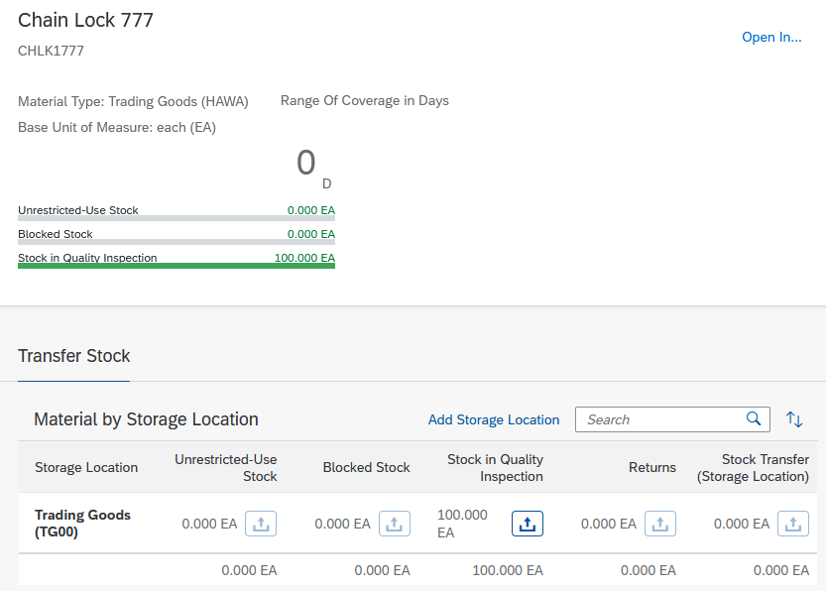
In the Stock in Quality Inspection column, click , next to the 100 units. The icon under Unrestricted use stock is now clickable. Click .
In the Transfer Stock – In-Plant window, increase the quantity to 100. |  | 100
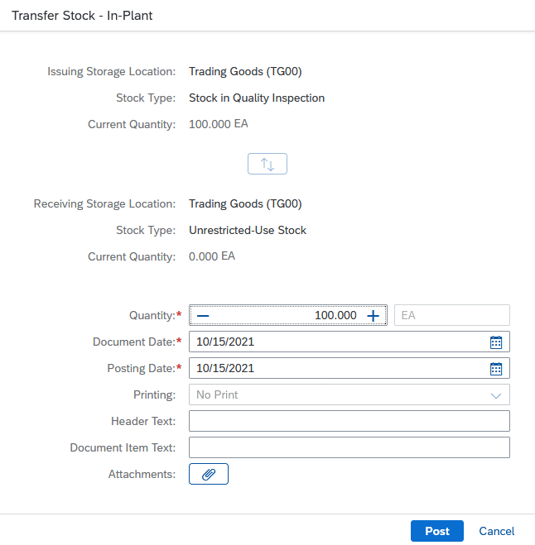
Click . You receive a success message. The material has been transferred.
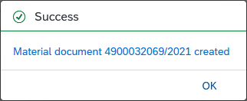
Close the message and click to go to the SAP Fiori launchpad.

 | Step 14: Check Physical Goods Receipt
Task Confirm the physical receipt of the goods.  Description View the inventory of chain locks again. The stock overview gives you an overview of the stocks of a material across all organizational levels.  Name (position) Tatiana Karsova (Goods Receipt Clerk) |  | Time 5 min
To check the stock level of a material, go to the Materials Management space. In the Goods Receipt Clerk section, you can use the Manage Stock app. |  | Start
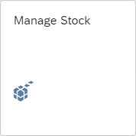
From the drop down menu, choose the DC Miami (MI00). To find the material number from your chain lock, click in the Material field and then click the value help icon. |  | MI00
In the Search field, enter *### (for example, if your number is 002, enter *002). |  | *###
Click to display the list of materials. Extend the Material Short Text field. Scroll down until you find your material CHLK1###. |  | CHLK1###
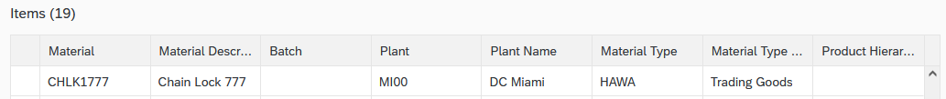
Double click on it. The report shows you the storage level for the DC in Miami.
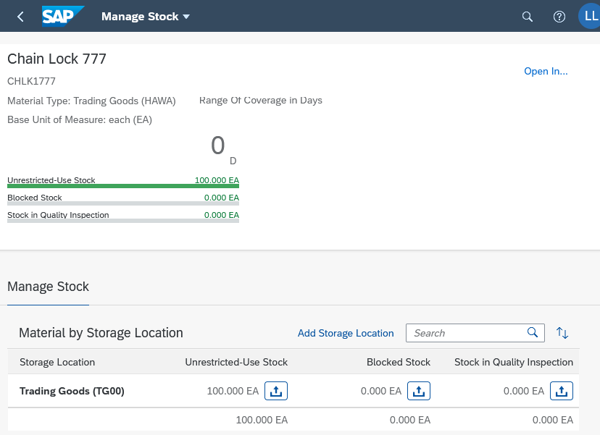
You can find out more details about the stock of the chain lock. To do so, click . This will give you detailed information about the stock of the chain lock in the different plants.
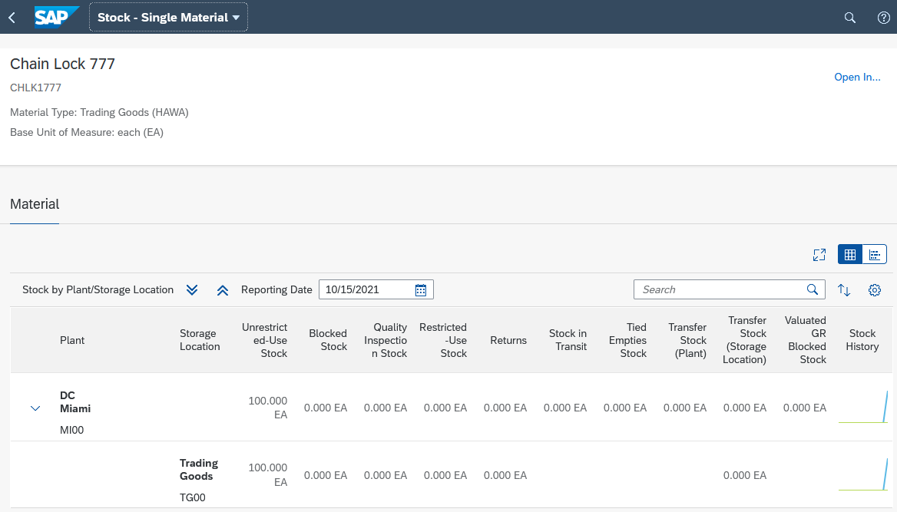
Click on the icon  at the DC Miami (MI00) plant to see detailed information about the stock of the chain lock in Miami. On the following screen, you can see a graphical overview.
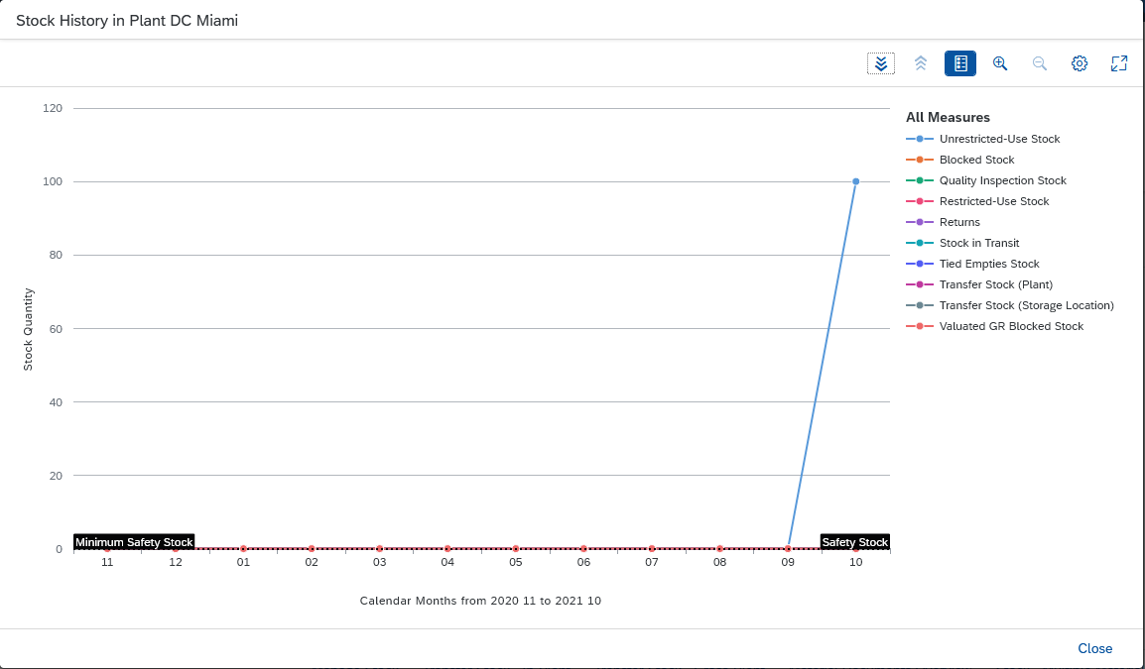
Click to go to the SAP Fiori launchpad.

 | Step 15: Create and Post the First Supplier Invoice
Task Create a supplier invoice.  Description Create a supplier invoice from Mid-West Supply for 3,200.00 USD for the current purchase order and the received goods. This invoice is assigned to an existing expense account in the general ledger of your chart of accounts and saved as a payable to Mid-West Supply. To facilitate data entry in the general ledger, the invoice is shown below.  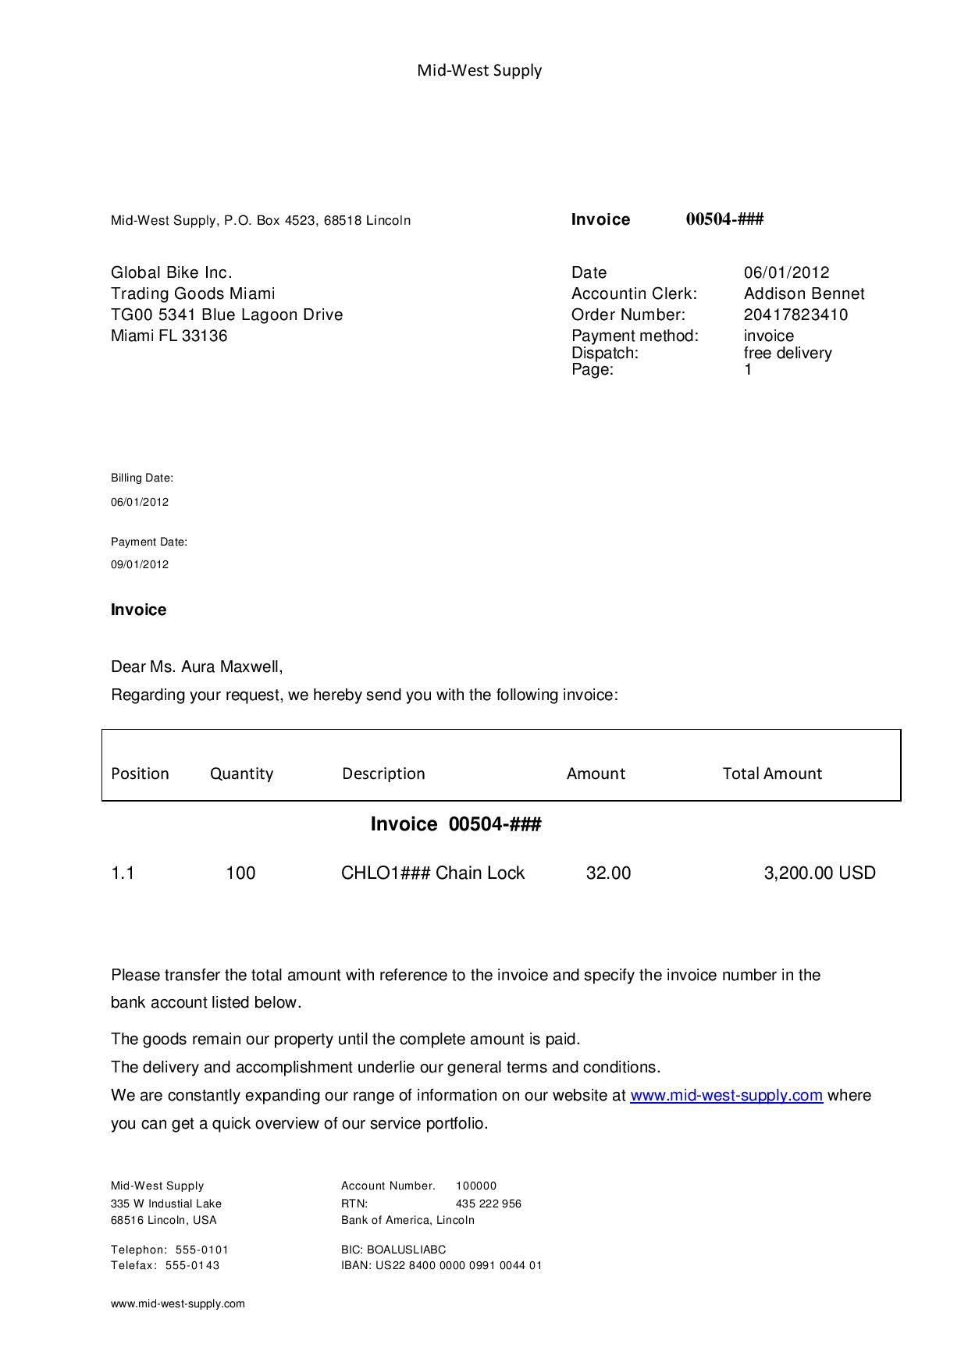  CHLK1### Chain Close  Name (position) Silvia Cassano (AP Accountant) |  | Time 5 min
To create a supplier invoice, please go to the Materials Management space. In the AP Accountant section, you can use the Create Supplier Invoice app. |  | Start
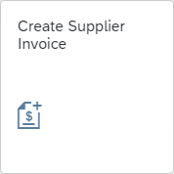
On the Create Supplier Invoice screen, enter today’s date as the Invoice Date. Check your company code US00. Enter the amount of the above invoice (3,200.00) in the Gross Invoice Amount field. Now enter INVOICE00504-### as Reference. |  | Today's date  US00  3,200.00  INVOICE00504-###
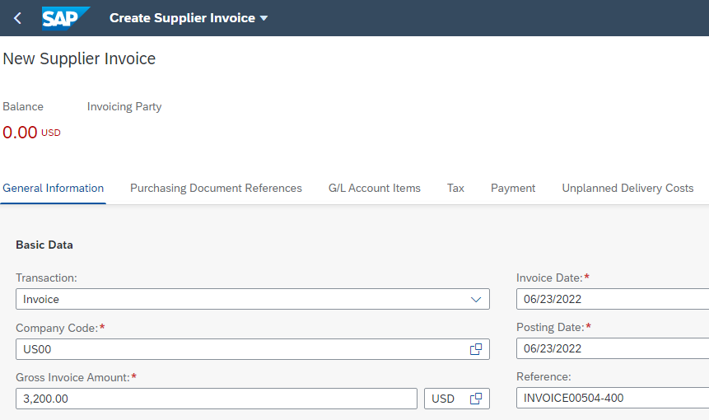
Go to the tab Purchasing Document References.
Now enter (or search for) the number of your purchase order in the Purchase Order/Scheduling Agreement field. Then press Enter. The Invoicing Party field has now been automatically filled with the number of your vendor. |  | Your purchase order number
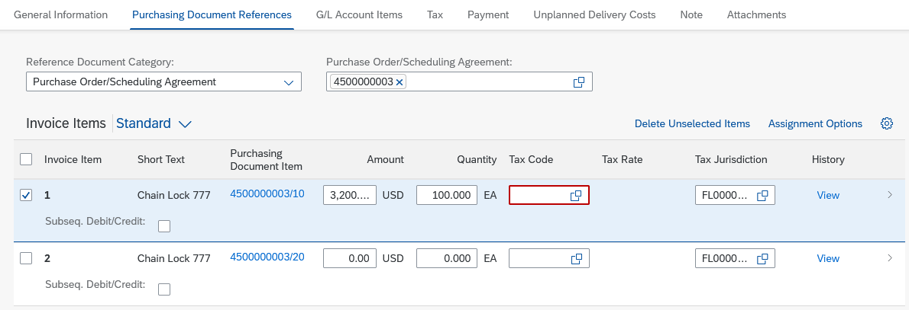
For the first invoice item, enter XI as Tax Code and TX0000000 as Tax Jurisdiction. |  | XI  TX0000000
Scroll back to the top of the page. As you can see, the balance is 0.00 USD.
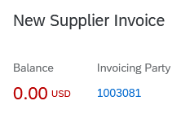
Then press to verify that your postings are correct.
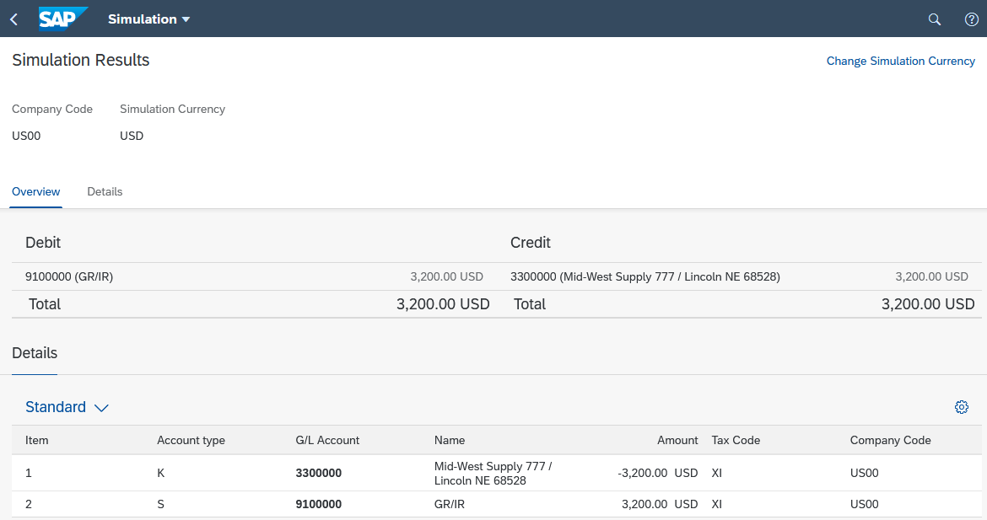
Finally, press . The system will generate a unique supplier invoice number.
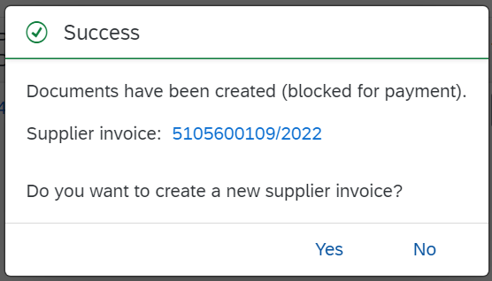
Close the message with No to return to the SAP Fiori launchpad.

 | Step 16: Display Purchase Order History
Task Display the purchase order history.  Description Review the status of your order of the chain locks. Due to the first transaction that was carried out for your purchase order number, the Purchase Order Processing tab page is now available in the purchase order.  Name (position) Wilton Saban (Inventory Supervisor) |  | Time 5 min
To display the purchase order history, go to the Materials Management space. In the Inventory Supervisor section, you can use My Purchasing Document Items (Professional) app. |  | Start
The app provides you with an overview of all purchase requisitions, purchase orders, goods receipts, and supplier invoices. In the Supplier field, enter your vendor Mid-West Supply ###. |  | Mid-West Supply ###
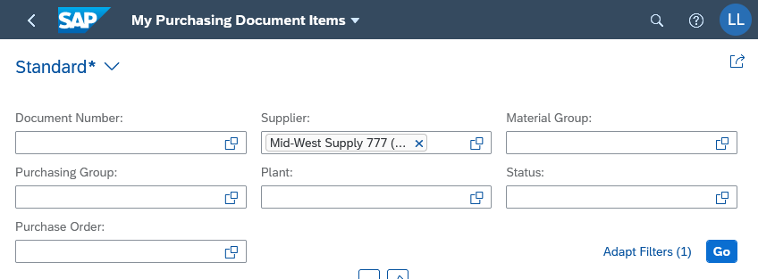
Choose and then choose the tab page . You may need to scroll down to see your supplier and purchase order.
In the Purchase Order Items area, click and select the Delivered Quantity and Delivered Amount columns in the View Settings dialog box.
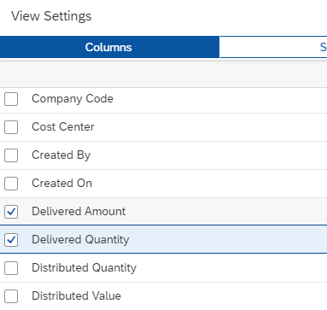
Click . As you can see, the first item of the purchase order has been delivered for a delivery value of 3,200 USD.
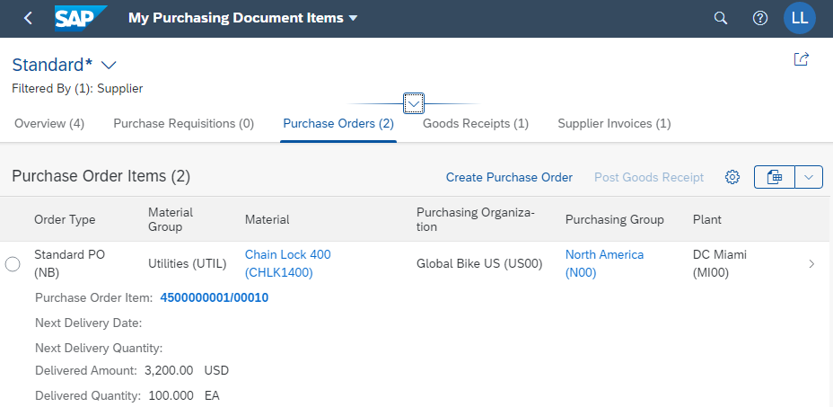
Now choose the tab page . You can see the 100 delivered chain locks. You see the material document that was created in the system when you confirmed the goods receipt.
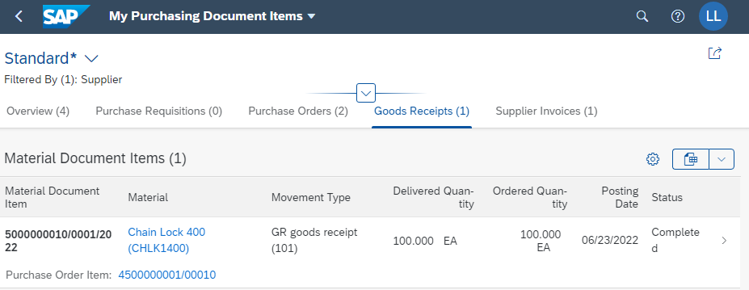
On the Supplier Invoice tab, you can see further activities that have been carried out with reference to your purchase order. Click .
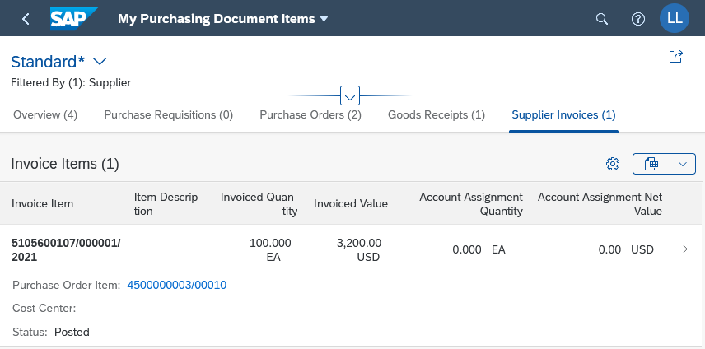
The invoice has been created. Click on the invoice line of your chain lock. This will take you to the financial document that was created when you created the supplier invoice.
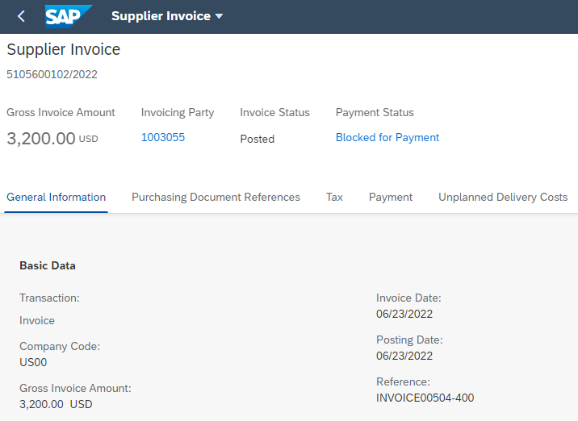
Click to go to the SAP Fiori launchpad.

 | Step 17: Display Document Flow
Task Display the document flow.  Description Check the goods receipt document and the document flow of your material.  Name (position) Wilton Saban (Inventory Supervisor) |  | Time 5 min
To display the history of documents, please go to the Materials Management space. In the Inventory Supervisor section, you can use the Material Documents Overview app. |  | Start
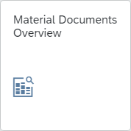
The app provides an overview of material documents. You can find your purchase order by using the assigned number. To do this, enter your material number CHLK1### in the Material field. If the search fields are not displayed in your system, first click to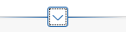 expand the search fields. |  | CHLK1###
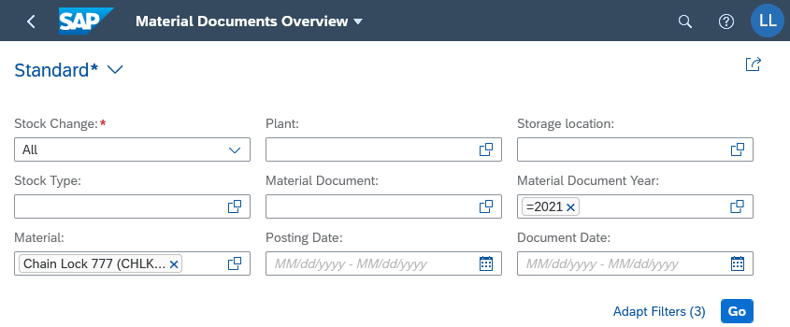
After entering the search term, click . Then click Settings. In the view settings, activate the Stock Type (Transfer) column. Confirm with. |  | Stock Type (Stock Transfer)
A new material document is created for each material movement. You see two material documents with your material CHLK###. One is the document for the goods receipt into inspection stock. You also see a document that was generated by the transfer posting of the material to unrestricted-use stock.
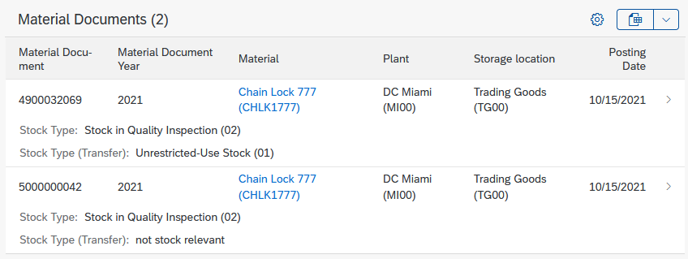
Identify the line with the Stock Type (Transfer): Unrestricted-Use Stock.
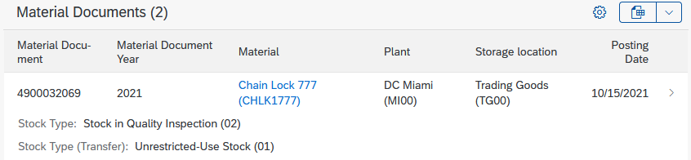
Click on this line. You can now see the general information for the document from the step in which you confirmed the goods receipt.
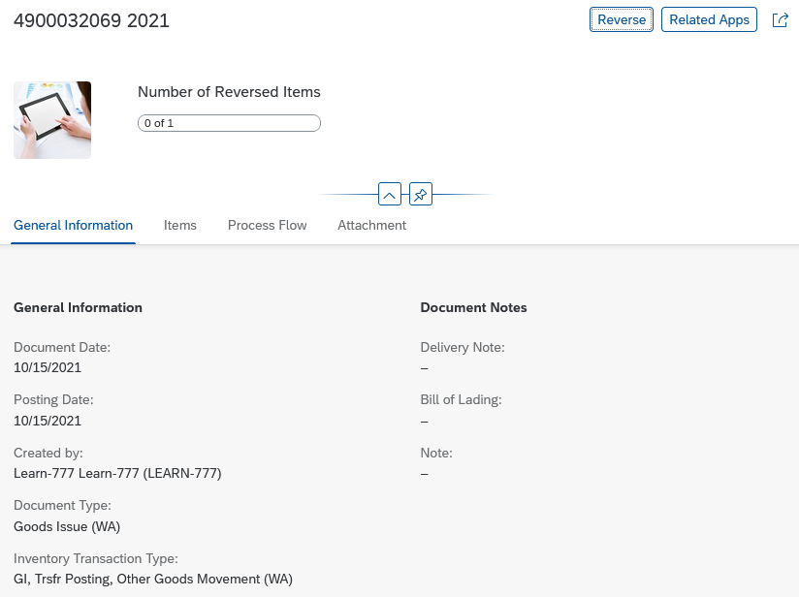
Click the Process Flow tab. In the process flow, you can see the transfer posting of the material from stock to quality inspection to unrestricted-use stock.
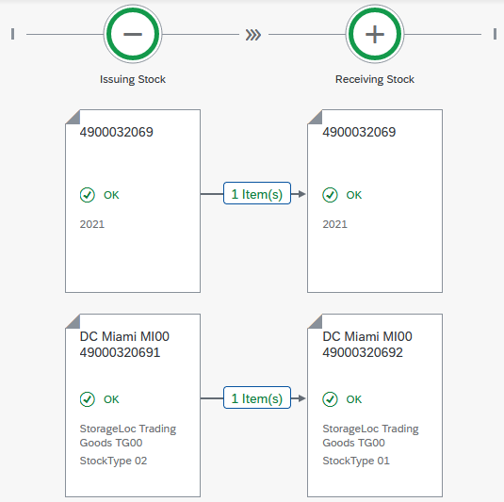
Click to go to the SAP Fiori launchpad.

 | Step 18: Post Goods Receipt for Purchase Order
Task Post a Goods Receipt for a Purchase Order.  Description You receive the missing goods that you ordered from Mid-West Supply into your warehouse. A goods receipt posting is created that refers to your purchase order. This ensures that you have received the ordered goods within the expected time and in the required quality. The stock is increased and a financial document is created that posts the value of the goods correctly.  Name (position) Tatiana Karsova (Goods Receipt Clerk) |  | Time 5 min
To post the goods receipt, please go to the Materials Management space. In the Goods Receipt Clerk section, you can use Post Goods Receipt for Purchasing Document app. |  | Start
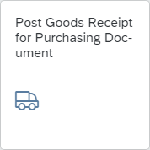
The Post Goods Receipt for Purchasing Document window appears.
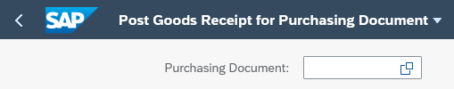
Choose the F4 help in the Purchasing Document field.
Enter your number *### and click . Search for your material CHLK1###. You can see that you no longer see two purchase orders but only one open purchase order for your material. |  | *###
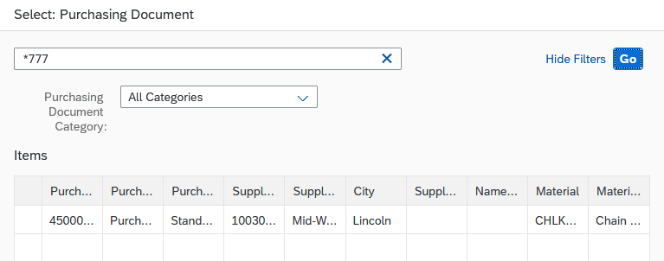
Double-click the purchase order. The following screen appears. On the "Items" tab page, you should see only one row.
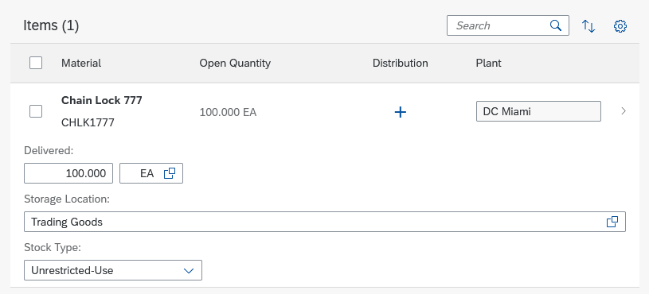
Make sure that for Storage Location TG00 (Trading Goods) and for Stock Type Unrestricted use is selected. |  | TG00  Unrestricted Use
Note In step 12, you first posted the goods in quality inspection and then inspected them later. In this scenario, you inspect the goods directly at goods receipt so that you can use them directly.
Click on the item line of your chain lock to check all entries. Select the Delivery Completed checkbox. |  | Delivery Completed
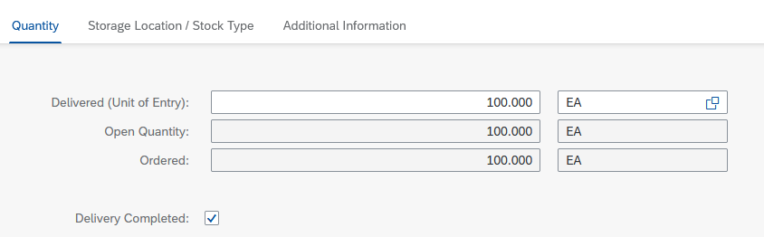
Now click . Select the line and click . You receive the following success message with your material document number.
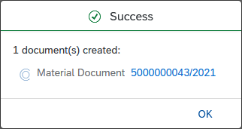
Close the messafe and click to go to the SAP Fiori launchpad.

 | Step 19: Check Physical Goods Receipt
Task Confirm the physical receipt of the goods.  Description View the inventory of chain locks again. The stock overview gives you an overview of the stocks of a material across all organizational levels.  Name (position) Tatiana Karsova (Goods Receipt Clerk) |  | Time 5 min
To check the stock level of a material, go to the Materials Management space. In the Goods Receipt Clerk section, you can use the Manage Stock app. |  | Start
From the drop down menu, choose the Miami plant DC Miami (MI00). To find the material number from your chain lock, click in the Material field and then click the value help icon. |  | MI00
In the Search field, enter *### (for example, if your number is 002, enter *002). Click to display the list of materials. |  | *###
Scroll down until you find your material CHLK1###. Double click on it. |  | CHLK1###
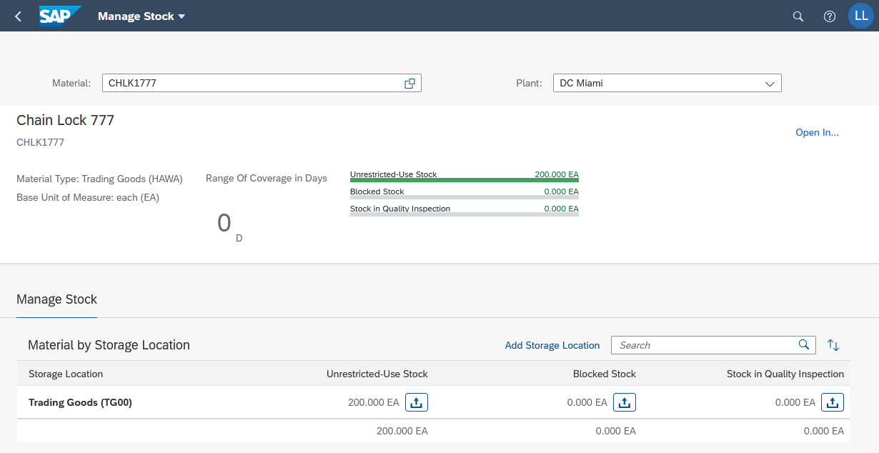
Since in the previous step the goods receipt was posted directly to unrestricted stock, you can see that the stock in this category has increased from 100 to 200.
You can find out more details about the stock of the chain lock. To do so, click . This will give you detailed information about the stock of the chain lock in the different plants.
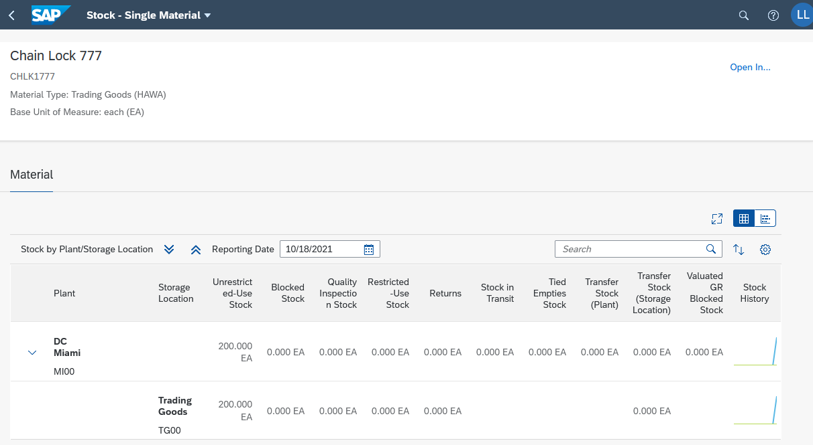
Click  to display the stock history for plant DC Miami (MI00) graphically. You can now see a graphical overview.
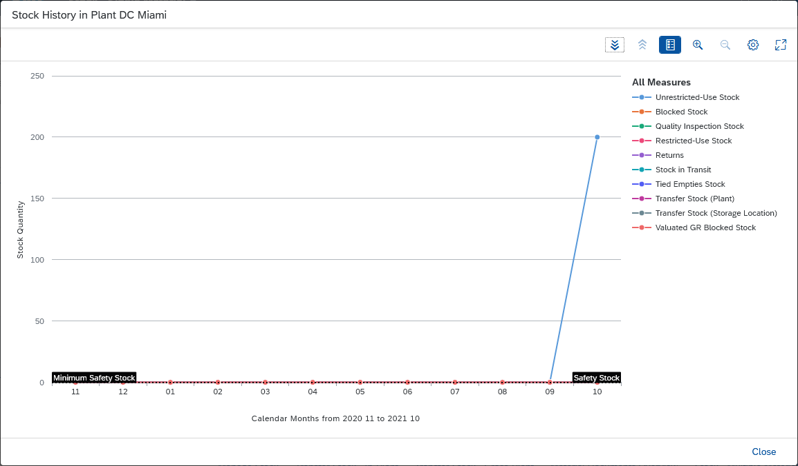
Since you currently only have unrestricted-use stocks, the key figures are set to 0.
Close and then click to go to the SAP Fiori launchpad.

 | Step 20: Create and Post the Second Supplier Invoice
Task Create a supplier invoice.  Description Create a supplier invoice from Mid-West Supply for USD 3,200.00 for the second partial delivery and the received goods. This invoice is also assigned to an existing expense account in the general ledger of your chart of accounts and saved as a payable to Mid-West Supply. Later, a check is issued for Mid-West Supply. To facilitate data entry in the general ledger, the invoice is shown below.  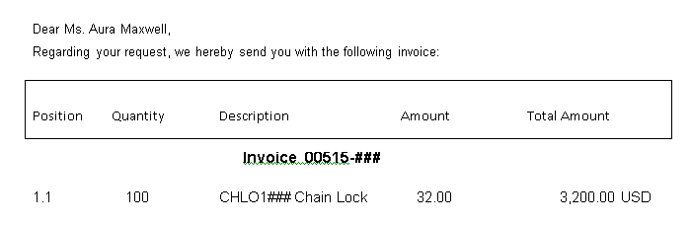  CHLK1### Chain Lock  Name (position) Silvia Cassano (AP Accountant) |  | Time 5 min
To create a supplier invoice, please go to the Materials Management space. In the AP Accountant section, you can use the Create Supplier Invoice app. |  | Start
On the Create Supplier Invoice screen, enter today’s date as the Invoice Date. Verify that company code US00 is selected. In the Gross Amount field, enter the amount of the invoice above (3,200.00). Enter INVOICE00515-### as the reference. |  | Today's date  US00  3,200.00  INVOICE00515-###
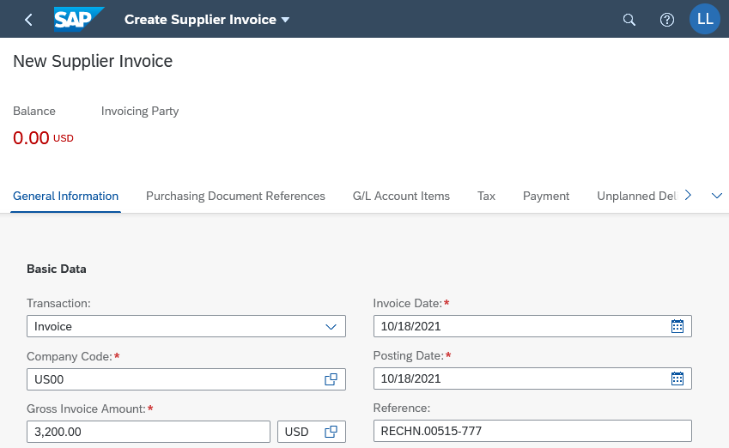
Choose the Purchasing Document References tab.
Now enter (or search for) the number of your purchase order in the Purchase Order/Scheduling Agreement field. Then press Enter. The Invoicing Party field has now been automatically filled with the number of your vendor. |  | Your purchase order number
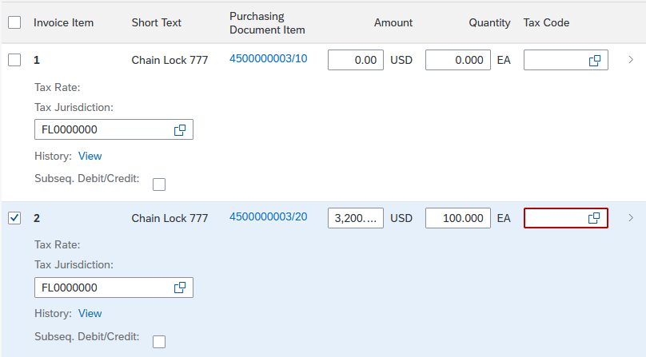
For the second item, enter XI as Tax Code and TX0000000 as Tax Jurisdiction. |  | XI  TX0000000
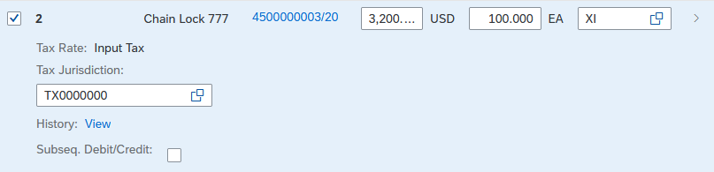
In the document header, you can see that the balance is 0.00.
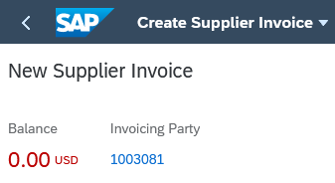
Then press to verify that your postings are correct.
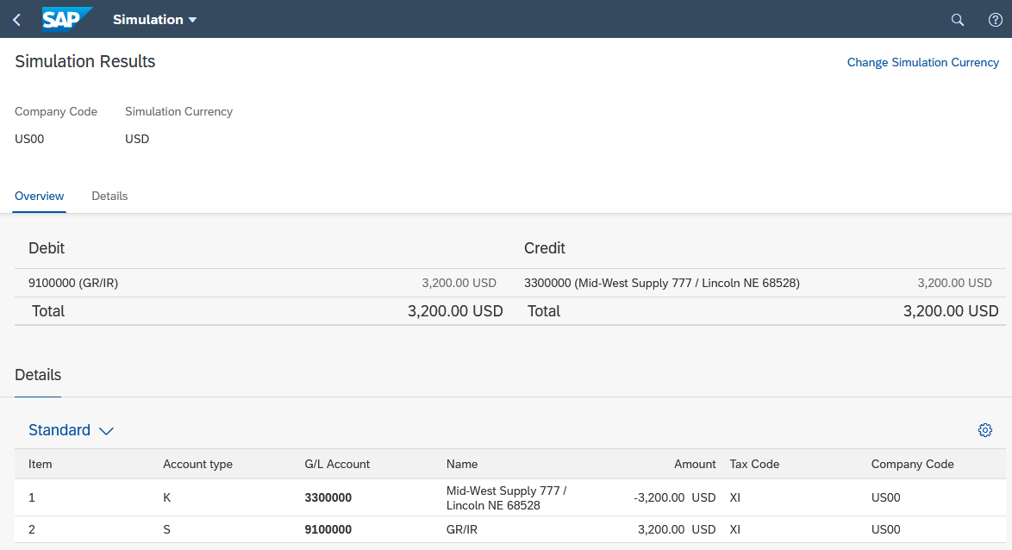
Finally, press and then No. The system will generate a unique supplier invoice number.
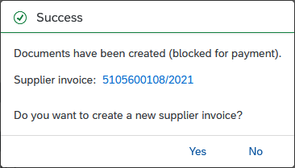
Click No to go to the SAP Fiori launchpad.

 | Step 21: Post Outgoing Payment
Task Post the payments to a supplier.  Description Issue a payment to your supplier Mid-West Supply to pay your payables. Note that the total amount is for both of your invoices. The created posting will clear the liability from your bank account.  Name (position) Silvia Cassano (AP Accountant) |  | Time 5 min
To post the payment to a supplier, go to the Materials Management space. In the AP Accountant section, you can use the Post Outgoing Payments app. |  | Start
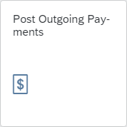
On the Post Outgoing Payments screen, choose Global Bike Inc. as the company code (US00). For Posting Date and Journal Entry Date enter today’s date, for Reference INVOICES ###, and the current period. For G/L account, enter 1810000 (Bank 1) and the Amount 6,400.00 USD. |  | US00  Current Date  INVOICES ###  Current Period  1810000  6,400.00 USD
Ensure that the journal entry type KZ (Vendor Payment) is selected. Use the following screenshot to check your entries. |  | KZ (Vendor Payment)
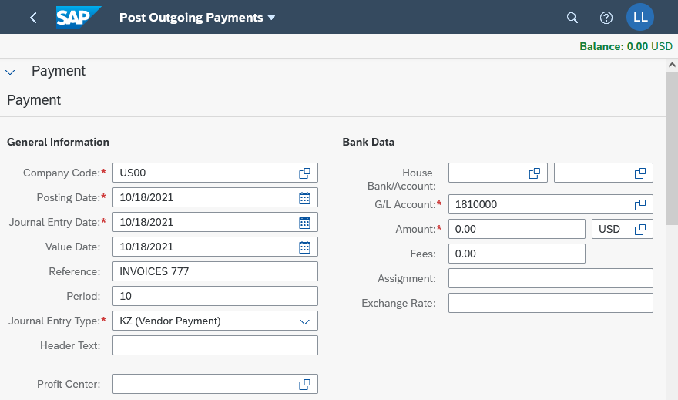
Under Open Item Selection, enter your supplier number for Mid-West Supply as the account (if necessary, use the F4 help). |  | Mid-West Supply
Click . On the upper right, you can see that the open balance is USD 6,400.00.
On the Open Items tab page, you see the two split deliveries.
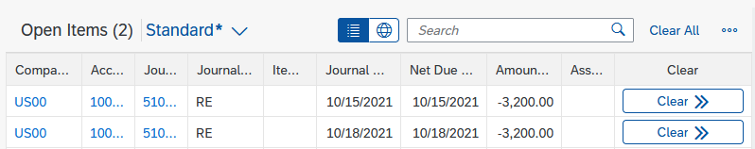
Since you want to pay both bills together, choose the button in both lines. Note that both items have been cleared.
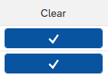
The open balance is now USD 0.00.
Press to post your payments to Mid-West Supply. The system will assign a unique document number to your supplier payment.
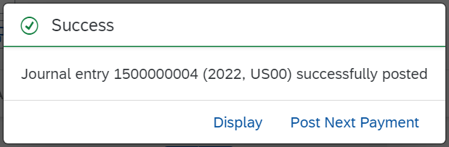
Press Display and click to go to the SAP Fiori launchpad. Confirm any error messages.

 | Step 22: Display Vendor Balance
Task Display the balances of a vendor.  Description View and confirm the activities and related balances related to your Mid-West Supply vendor. You should see a debit posting and a credit posting that were generated by the two invoices and the output of a single payment to settle the payables to Mid-West Supply.  Name (position) Shuyuan Chen (Head of Accounting) |  | Time 5 min
To display the balances of a vendor, please go to the Materials Management space. In the Head of Accounting section, you can use the Display Supplier Balances app. |  | Start
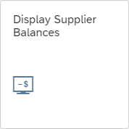
Use the F4 help in the Supplier field to find the number of your supplier. In the Search Term field, enter your number ### and press . |  | ###
Scroll until you find your vendor Mid-West Supply. Select the entry. |  | Mid-West Supply
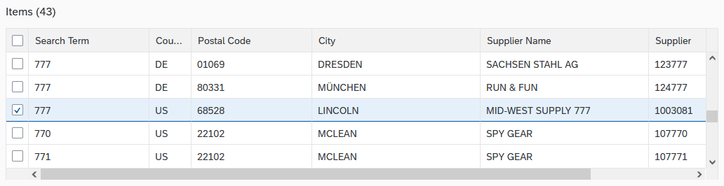
Confirm with . Back on the Display Supplier Balances screen, choose US00 as the company code and the current year as the fiscal year. |  | US00  Current Year
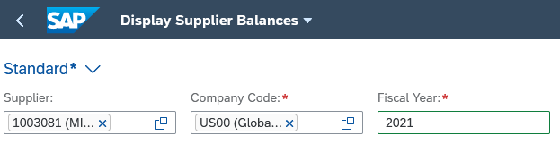
Then choose to display the balances. You get a similar overview.
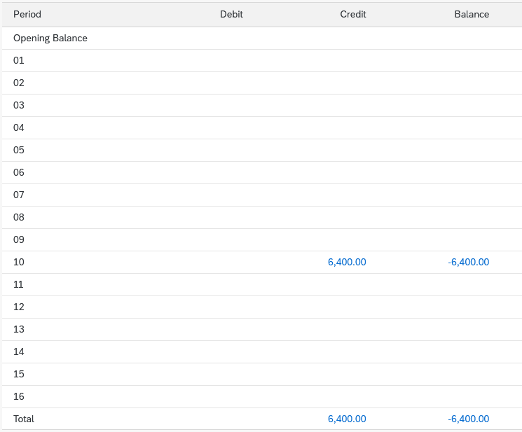
Click to go to the SAP Fiori launchpad.

 | Step 23: Display Purchase Order History
Task Display the purchase order history.  Description Review the status of your order of the chain locks. The Purchase Order History tab page has been updated as a result of further postings.  Name (position) Wilton Saban (Inventory Supervisor) |  | Time 5 min
To display the purchase order history, go to the Materials Management space. In the Inventory Supervisor section, you can use My Purchasing Document Items (Professional) app. |  | Start
The app provides you with an overview of all purchase requisitions, purchase orders, goods receipts, and supplier invoices.
In the Supplier field, enter the number of your supplier Mid-West Supply ### and choose . |  | Mid-West Supply ###
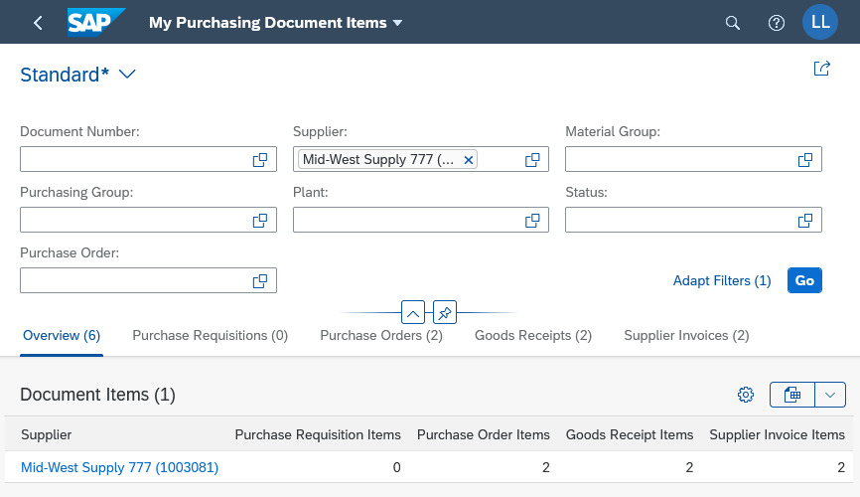
Click . You may need to scroll down to see your supplier and purchase order.
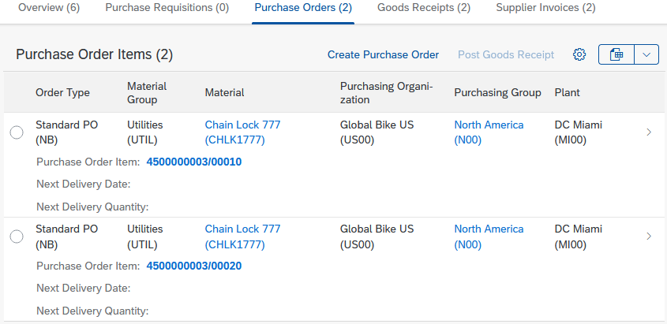
As you can see, no more open quantities are displayed under Next Delivery Quantity.
Click. You see the other 100 delivered chain locks. You also see the material document that was created in the system when you confirmed the goods receipt.
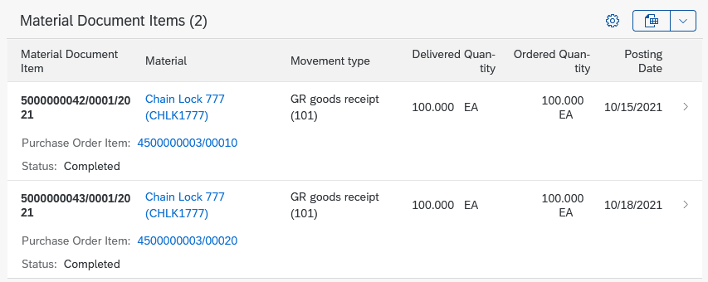
In the Supplier Invoice Overview, you can see further activities that have been performed with reference to your purchase order.
Click . Both invoices have been created and have the status Posted.
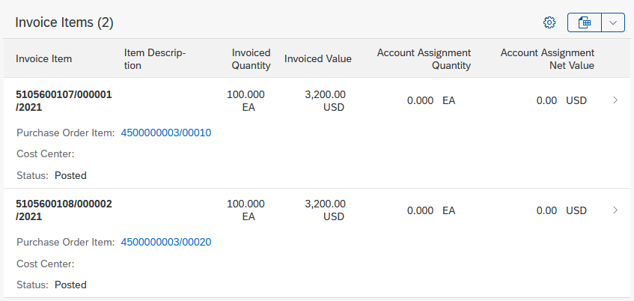
To display more information about the documents, you can click on the relevant row. This will take you to the financial document that was created when you created the supplier invoice.
Click to go to the SAP Fiori launchpad.

 | Step 24: Display Balance List and Line Item List
Task Display the balance and line item list of the general ledger.  Description Use G/L account numbers to display the activities and related balances for some accounts in your general ledger.  Name (position) Shuyuan Chen (Head of Accounting) |  | Time 5 min
To display the balance and line item list, please go to the Materials Management space. In the Head of Accounting section, you can use the Balance Sheet/Income Statement app. |  | Start
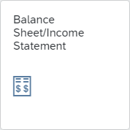
In the Display Financial Statement screen, enter US00 (Global Bike Inc.) for Company Code, 0L for Ledger, and G000 for Financial Statement Version. Make sure that the Balance Sheet Type is Normal (Actual - Actual) and End Period is current period/year and Comparison Period is 1/2016. Compare your screen with the following screenshot. |  | US00  0L  G000  Normal (Actual – Actual)  Current Period/Year  1/2016
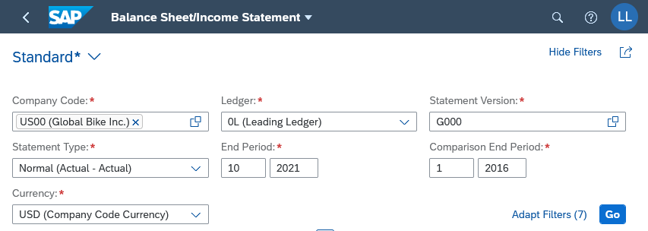
Choose . In the view, you can see all items of the accounts of Global Bike in the United States.
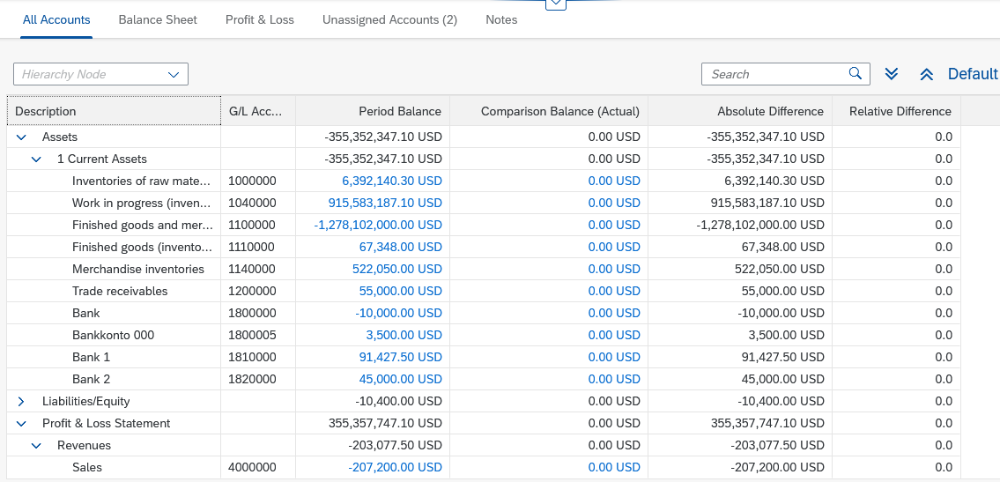
Note Since all participants in your course are posting to the same US bank account, the number you see next to the bank account 1810000 used is different.
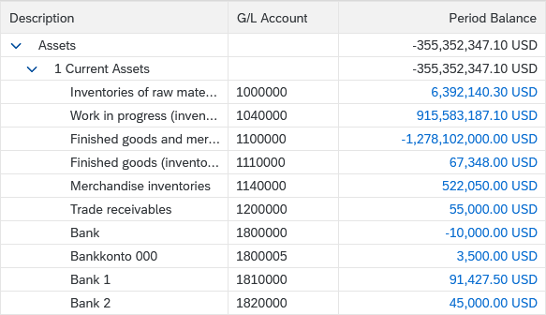
Click to go to the SAP Fiori launchpad.

 | MM Challenge
Learning objective Understand and execute a Materials Management process. |  | Time 80min
Motivation After you have successfully completed the Materials Management case study, you should be able to solve the following task independently.
Scenario A new chain lock, Chain Lock Security Pro ### (DE: Kettenschloss Security Pro ###), is available on the market and we would like to include it in our inventory. The new chain lock with material number CHSP1### consists of a higher quality steel than the previous chain lock (CHLK1###), but the old one can still be used as a template because it has the same properties. The new material is intended for plant MI00, sales organization UE00, and distribution channel WH. With modern production techniques, the new material CHSP1### is also offered more cheaply by the suppliers. Global Bike Inc. passes the savings on to its customers. Maintain the chain lock in Sales and Distribution with the price condition 50.00 USD per chain lock. Request offers for 300 chain locks of security pro with a valuation price of 25.50 USD. Based on your request of 300 pieces, Boomtown Tire & Wheel is offering 26.00 USD per piece and Space Bike Composites of 25.50 USD per piece. Enter both quotations and accept the best quotation and order the requested 300 chain locks. Process the inbound delivery and enter the incoming invoice. You then pay for the delivery.
Note Since this task is based on the Materials Management case study, you can use this as a guide. However, we recommend that you carry out this continuing task without assistance in order to test your acquired knowledge.

